**Contractor Engagement Process**

**Society Contractor Policy**

All contractors must be onboarded and managed using the Society Contractor Management Processes.

No contractor can be engaged, extended or terminated without following these processes.

Active Directory (AD) accounts are auto managed by the creation and accurate maintenance of the IFS contractor record, which enables AD account creation, extension, disabling and deletion.

**Contractor Types**

Always check the contractor type so you know what process to follow, what information is required and what checks to make.

***Important*** *The following process overview covers engaging an agency contractor. The same process should be followed for engaging a self-employed or PSC contractor, but with the contractor registering and applying rather than any third party.*

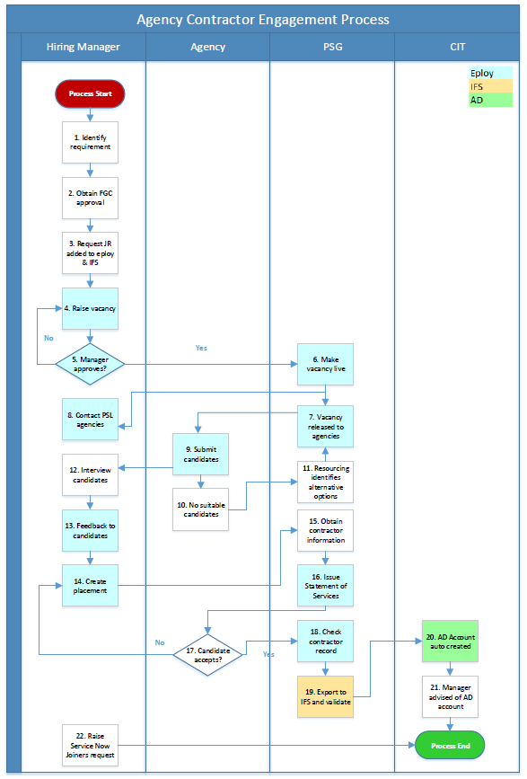

**Process Overview**

The Contractor Engagement process enables the onboarding of contractors in a manner compliant with the Society’s contractor management policy.

This process applies to the onboarding of direct (self-employed), Personal Service Company (PSC), agency and temp contractors.

**Process differences depending on contractor type**

**Temp Contractors**

The same process and steps apply for temps as for agency contractors. The Type of Hire to select is Temp Contractor, and you will select hourly pay rate rather than daily when creating the placement.

**Direct Contractors**

The same process and steps apply for direct contractors as for agency contractors. The Type of Hire to select is Direct Contractor, and there is no agency involvement, ie, the contractor registers, applies and completes all onboarding actions.

Refer to the Contractor Management right to work guidance and the data elements table to be clear on the different data and document requirements that each contractor type has.

**Manager Process Steps**

**1. Identify requirement**

You have identified a requirement for resource and have decided that a contractor is the best way to fill the vacancy.

**2. Obtain FGC approval**

Finance governance approval is required for new capital expenditure. Contact your manager if you need guidance on whether / how FGC rules apply in this situation.

**3. Request JR added to eploy & IFS**

To be able to progress a new contractor engagement, check first that the job role exists in eploy to be able raise the vacancy. You can do this by viewing the available job role templates in eploy when first creating a vacancy.

If the job role does not exist, then a role profile will need to be written so this and the job role can be added to eploy and IFS. Contact the Society resourcing team via [hiringmanagersupport@midcounties.coop](mailto:hiringmanagersupport@midcounties.coop) for guidance on how to do this.

**4. Raise vacancy**

Log into eploy and click on Create from Template.



You will be asked to specify whether your vacancy is a contractor role or not.

Always click Yes for a contractor role.

***Important*** *If you are raising an employee vacancy (ie, you want to employ an individual on a fixed term or permanent contract), please do NOT click Yes to the ‘Is this a contractor role’ question. If you do this can cause significant issues with the employee exporting to the IFS system as a contractor, and can cause delays with starting and potentially payments.*

Click SELECT, next to *Load From Template 

This will load a drop-down list of all the vacancy templates that you will have access to.

Click on the vacancy template that you need, then click Continue.

The vacancy template will load in full. Please review the information that has populated before proceeding.

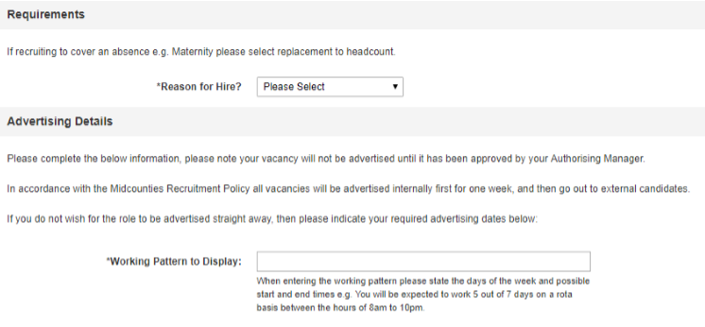

Click on the dropdown list next to Reason for Hire and select the relevant option. If you are raising a vacancy to replace a colleague, you must state their name.

You will also need to enter the working pattern in Working Pattern to Display.

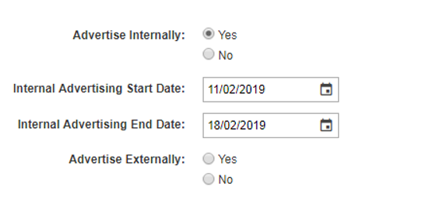

Click Yes next to Advertise Internally and enter the advertising dates that you would like your vacancy to go live for.

Repeat this step for Advertise Externally.

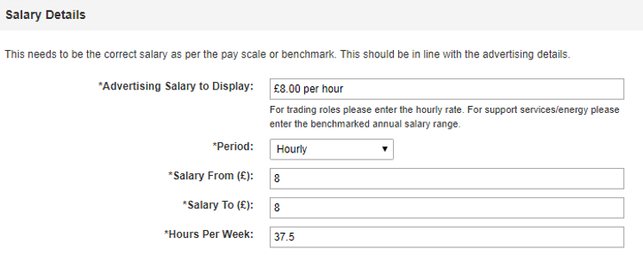

In Advertising Salary to Display, enter the salary you want to advertise for your role, e.g. “£8.00 per hour”. Please ensure the pound sign, ‘£’, is included when you enter this information.

Click on the dropdown list beside Period – select Daily for self-employed contractors, and select Hourly for those contractors that are hourly paid / charged for.

The Salary From and Salary To are ranges for your salary. If your salary has no range, enter the same figure into both fields. If your salary does have a range, enter the lower figure into Salary From and the highest figure into Salary To.

Enter the weekly hours for your role into Hours Per Week.

*As the role is for a contractor, you may not know the pay rate at this stage. If this is the case, then Advertising Salary to Display can be entered as ‘To be agreed’ and Salary From and To can be entered as 0.*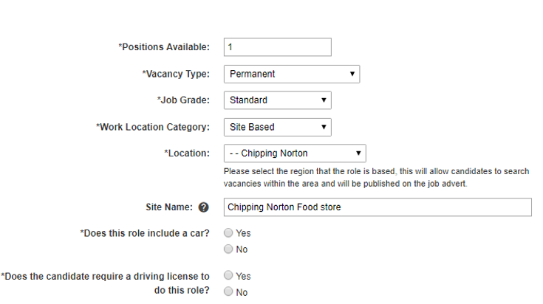

Complete Positions Available with the number of positions you are advertising for.

***Important*** *Select Contractor in Vacancy Type.*

You will need to state the length of the contract duration, in weeks.

Repeat the same step for Job Grade and Work Location Category

Location will feed into the vacancy advertisement. Click the dropdown list and select the town/city your where your site is based.

If you site is located in an area with several other Midcounties branches or if you would like to specify the name of your location, you can enter the name of your store into the Site Name field e.g. “Cowley Road Food store”.

If your role requires the use of a car, click Yes, this will bring up the Estimated annual mileage which you will need to provide using the dropdown list.

If you candidate needs a driving licence for the role, click Yes.



Enter a Proposed Start Date if you have a provisional start date in mind for this vacancy. This is not a mandatory field so leave blank if you do not have a date to enter.

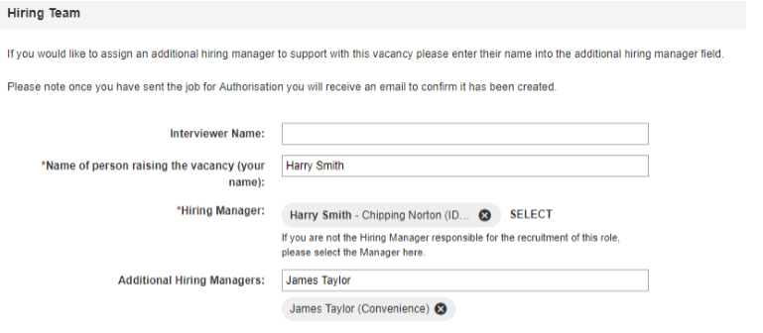

Enter the Interviewer Name, this can be you as the manager or if someone else is interviewing candidates on your behalf, enter their name here.

If you are raising the vacancy on behalf of someone else, remove your name next to Hiring

Manager by clicking on the  and click SELECT to search the name of the relevant manager. Click on the name when you have located them.

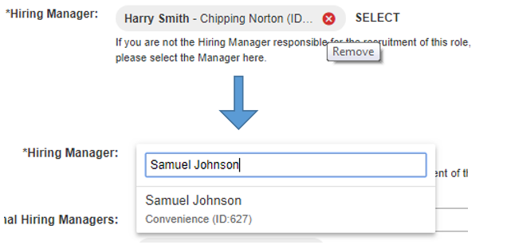

If another manager is assisting you with the recruitment for this vacancy, enter their name into the Additional Hiring Managers and click on the name when it populates; you can add more than one manager.

Confirm whether the role has been approved by Finance Governance by selecting the relevant option from the FGC approval obtained dropdown.

If yes, provide the FGC Capex Number. If No, state the reason why.



Click Continue to proceed or Save As Draft if you are not proceeding for now.

You will be redirected to a page where you can select who will authorise our vacancy.

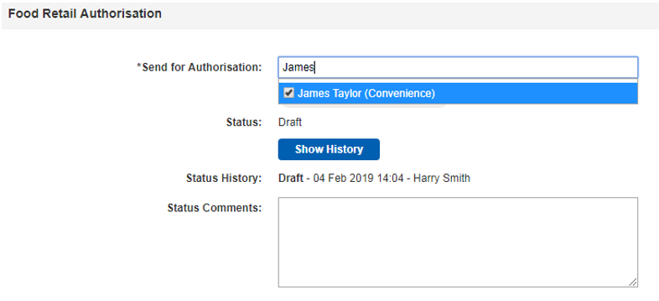

Enter your authorising manager’s name into the Send for Authorisation field and click their name when it populates. In most cases, this will be your line manager; if your line manager is away, please select an alternative manager.

You can always add a comment in Status Comments if you wish to provide any further information.

Click Send for Authorisation when you are happy with your vacancy information.



Your authorising manager will be notified by email that there is a vacancy for them to authorise. You will be notified by email as to whether your vacancy has been approved or not. If approved, your vacancy will now be with your Personnel Administrator, who will check the vacancy and set it to live

**12. Interview candidates**

Interview applicants as required, updating eploy regarding candidates invited for an interview. Refer to the full eploy hiring manager user guide for full details on how to perform these steps.

**13. Feedback to candidates**

After applicant interview, update eploy with the results of each interview. Refer to the full eploy hiring manager user guide for full details on how to perform these steps.

**14. Create Placement**

When placing a contractor to your vacancy, you will be required to complete several different pieces of information compared to a new employee starter.

Ensure that you have uploaded the contractor’s right to work if applicable, depending on the contractor type. Refer to the Right to Work guidance on the Contractor Management guidance on Colleagues Connect.

**Employment Status Assessment**

***Important*** *If you are looking to engage a contractor who has stated they are self-employed or under a Personal Service Company (PSC), you* ***must*** *complete an employment status assessment.*

One of the key ways that the Society mitigates employment law and tax risks is by establishing the contractor’s employment status.  By making this assessment, you are then able to determine whether to engage and if so under what circumstances.  Note that for agency, temp and service contractors, the individual is employed by a separate company, and so no employment status check is required – the employment status check only applies to direct contractors, ie, self-employed and Personal Service Company (PSC) contractors.

Go to the HMRC CEST system via the below link – CEST stands for Check Employment Status for Tax.  The questions will assist you in understanding whether the contractor is self-employed or could be deemed an employee under the terms of the proposed engagement.

<https://www.tax.service.gov.uk/check-employment-status-for-tax/reason-for-using-tool>

You can also refer to the HMRC guidance on checking and understanding employment status.

<https://www.gov.uk/guidance/check-employment-status-for-tax>

Go to the HMRC CEST tool.

For the first question ‘Which of these describes you best?’, enter ‘the end client’.

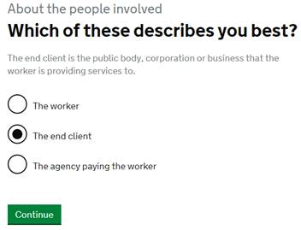

Answer the questions as prompted – it should take you no more than a few minutes to complete.

You will receive an automated result once you have completed all questions.



If the result is ‘intermediaries legislation does not apply to this engagement’, then you can engage the contractor as a self-employed contractor.

If the result is ‘intermediaries legislation does apply to this engagement’, then the contractor may be deemed to have an employee status.  To continue to engage as a self-employed contractor, review the terms of the engagement and ensure that the contract reflects any changes that mitigate any employment law and / or tax risks.

If you are in any doubt about the questions, answers, result or what to do next, please contact the Society Tax Manager.

Copy and paste the result including the questions and answers below the results box, into a word document. Sign and date the front page to confirm when the check was done by and by whom.

Save the document as CEST Results [today’s date] and upload to eploy as part of placement actions.

Once you have completed the employment status assessment or have deemed it not applicable, proceed with placement …

Click Create Placement Now.



The placement screen will load with the basic information regarding your contractor vacancy.



Complete the Start Date and End Date.

Select the appropriate Contractor Type of Hire. If you are unsure of the contractor type, refer to the contractor definitions in the Contractor Management guidance on Colleagues Connect.

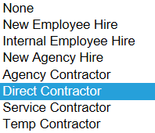

Your page will alter with extra information that you will need to complete.

Enter the Daily Salary.



Confirm whether an AD Account is required or not.



***Important*** *This will automatically create your contractor’s AD account after the IFS contractor record is created following successful placement, offer acceptance and export to IFS.*

Provide the Cost Centre and Right to Work details.



You will need to confirm whether a VAT Registration Number has been checked/required.



If the Company Registration Number has been verified or required.



If an Employment Status Questionnaire has been completed via the HMRC CEST tool, and whether this confirms the self-employment status of the contractor.



Upload the results of the Employment Status Questionnaire if your contractor is self-employed.



Confirm and upload a Childcare Request for Temporary Agency Cover Form if necessary.



Confirm and upload Proof of Insurance if necessary.



Review your placement information and click Continue, then Send to HR.

Your placement will go through to your Personnel Administrator.

**22. Raise Service Now Joiners request**

IFS contractor record creation automatically creates a disabled AD account, and the Joiners Movers Leavers (JML) process then enables the created AD account.

***END OF PROCESS***

**Document Control**

|  |  |
| --- | --- |
| **Document Version** | 2.0 |
| **Process Owner** | Aly Hull |
| **Document Maintainer** | Aly Hull |
| **Date Last Updated** | 05/12/2019 |
| **Last Updated By** | Ali McCreery |
| **Date Next Review** | 05/12/2020 |
| **Document Location** | Available on colleagues connect, with master held on B drive > PSG > PSG Shared Area > Resourcing > Contractors > IFS Contractors Project |

***END OF DOCUMENT***