Contractor Extension Process

Society Contractor Policy
All contractors must be onboarded and managed using the Society Contractor Management Processes.
No contractor can be engaged, extended or terminated without following these processes.
Active Directory (AD) accounts are auto managed by the creation and accurate maintenance of the IFS contractor record, which enables AD account creation, extension, disabling and deletion.

Contractor Types
Always check the contractor type so you know what process to follow, what information is required and what checks to make.

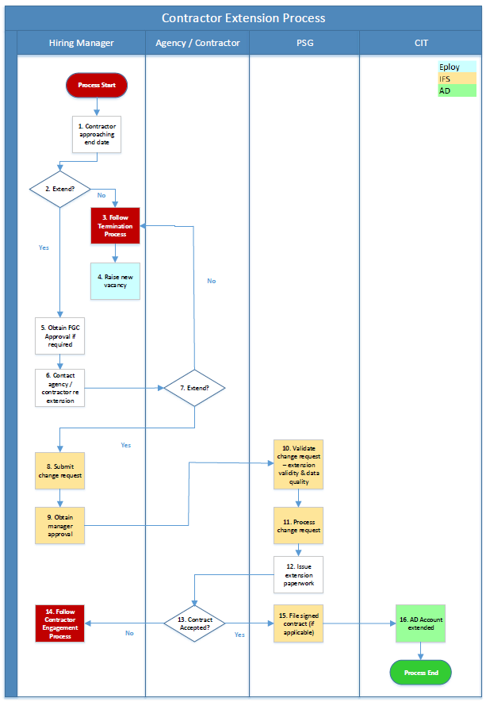

Process Overview
The Society’s contractor management process requires managers to review whether an extension to the current contract is appropriate, and then submit either an extension request or termination form depending on the decision. If the contractor is being terminated, follow the Contractor Termination Process.
The following guidance corresponds to the relevant process step in the process overview diagram.

Manager Process Steps

1. Contractor approaching end date
All contractors by their nature should have a contract end date. Engaging contractors on ‘open-ended’ contracts potentially exposes the Society to employment law risks. If you are unsure, refer the query to the Society’s tax and legal experts.
To view a contractor’s current end date, enter IFS and go to the contractor record.
Click on the Employment tab then the Periods tab, then view the End Date.
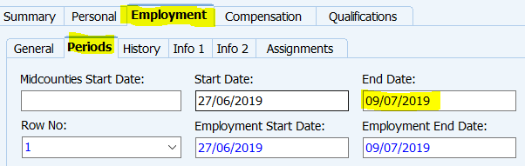
You will also receive automatic IFS email reminders as the contractor’s manager, reminding you of a contractor’s approaching end date. These reminders will be send 6 weeks before the current end date, 4 weeks before, 2 weeks before, 1 week before, 3 days before and on the day of the end date.
Your manager will also receive automatic IFS email reminders 3 days before your contractor’s current end date and on the day of the end date.
Important If your contractor has a current AD account, this will be automatically disabled if the contractor’s contract end date passes without extension. If the contract end date is still not extended 30 days after the account has been disabled, the account will automatically be deleted. The only way then to obtain a new AD account is to follow the full new contractor engagement process from the start.
2. Extend?
The contractor extension process applies to the following.
- Contracted hours – less relevant for contractors than employees but still applicable to some contractor types and contractor engagements.

- Pay rate – daily for direct and PSC contractor, hourly for agency and temp contractors, and not applicable for service contractors.

- Contract end date.

If other details of the contractor engagement change, this may require a new contract or re-engaging the contractor as a new contractor through the full new contractor process. Refer to the Contractor Extension Criteria in this document to assist you in making the decision on whether to extend the contract or not.
3. Follow Termination Process
If you wish to terminate the contractor’s contract either in line with or before the end date, follow the Contractor Termination Process.
4. Raise new vacancy
If the work has been completed, there is no requirement to raise a new contractor vacancy. If the work has not been completed or there is a new requirement, raise a new contractor vacancy to engage a new contractor.
5. Obtain FGC approval
Finance governance approval is required for new capital expenditure. Refer the contract extensions criteria and contact your manager if you need guidance on whether / how FGC rules apply in this situation.
6. Contact agency / contractor re extension
Before submitting a change request, you will need to confirm with the contractor, agency or service company, whether the other party wishes to extend. This may also include negotiation on pay, hours or other terms & conditions.
If no agreement can be reached with the other party regarding the extension, then follow the contractor termination and new contractor processes as appropriate.
8. Submit change request
The following guidance will help you in submitting a contractor extension request.

Enter IFS.

Enter the IFS contractor record.

Right click anywhere on the contractor record.

Select Employment Data Change.

A change reference number will be automatically created.

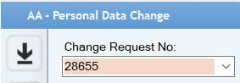

The request status will currently show as blank.

Enter the new information in the Proposed Data section
Important As with employment data changes for colleagues, only ever enter the information that is changing.
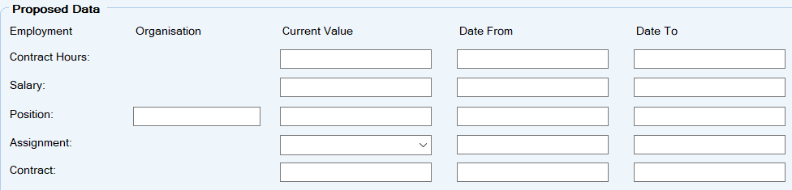
Contract Hours
Click in the field on the Contract Hours line in the Current Value column, then click on the List of Values (LoV) button and select the new weekly hours.
Enter the effective date of the change (Valid From) but leave the Date To as 31/12/9999, as this does not affect the contractor’s end date in IFS.
Pay rate
Click in the field on the Salary line in the Current Value column, and enter the new pay rate.
Contract End Date
This will be the most common type of contractor change, ie, the contract is extended but all other elements remain unchanged.
Important For a contract extension, complete both the assignment and contract lines. If just the assignment line is completed, this extends the assignment but not the contract end date and can cause an error which means the request has to be processed manually.
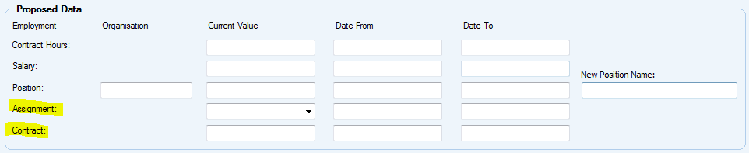
Assignment line – select Contractor in the drop down list in the Current Value column. Enter Date From and Date To as the effective date and new assignment end date respectively. The Date From and Date To should always match the Contract Date From and Date To.
Contract line - click on the field on the Contract line in the Current Value column, then click on the LoV button. You will always select Contractor.
Enter the effective date of the change in the Valid From field, and the new contract end date in the Valid To field.
Once the required information has been entered in the Proposed Data fields, click on the Save icon.
Right click on the contractor record, and click on Send for Approval.
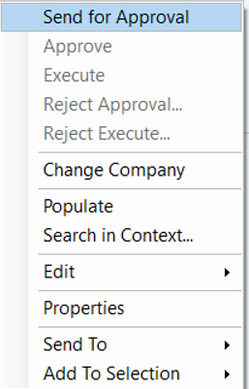
The request will be routed to your manager for approval. If approved, it will be automatically routed to your Personnel Administrator for processing.

Contractor Extension Criteria
When deciding whether a contractor’s contract should be extended or not, several factors should be considered. If the role / work is unchanged from the initial engagement (covered by the existing contract) and there have been no changes to either the relationship between the Society and the contractor, and no changes to the contractor’s employment, tax or legal status, then the contract extension should be straightforward.
The decision on whether to extend or not purely based on contract length is misleading. The below guidance is designed to assist you in making this decision, but if you are not sure, request further guidance.

Has the work been completed?
Yes - terminate by completing the contractor termination form and emailing to your PSG Administrator for processing.
No - consider contract extension according to the following guidance.

Will the work be completed by current contract end date?
Yes - plan to terminate nearer to but before the current contract end date.
No - consider contract extension according to the following guidance.

Do you require Finance Governance Committee (FGC) approval?
If the role is subject to FGC approval (and most are) and the extension takes the total contract cost to either above the original FGC approved spend, and / or above the £25k limit, then FGC approval is required.

Does the scope of the work change if the contract is extended?
Yes - then a new contract is required – raise an IFS employment data change request and include in Comments that a new contract is required. Followup with an email to your PSG Administrator with the details of what is changing, and a new contract will be issued by PSG Admin.
No - then a contract extension can be processed without the need for a new contract – raise an IFS employment data change request and include in Comments that a new contract is not required, and a contract extension letter will be issued by PSG Admin.

Is the contractor agency or temp and the extension will keep them under 12 weeks contract duration?
Yes - then extension is fine, subject to normal business affordability / finance governance approval.
No - then the 12 week Agency Worker Regulations (AWR)* applies and the contractor should either be terminated, or reviewed as to whether conversion to employee is appropriate. If yes, the new colleague hire process should be followed.

Has the relationship between the Society and the contractor changed in any significant way?
This can include changes to mutuality of obligation, right of substitution, control (actual and perceived) of the Society over the contractor, and any other changes that could change the contractor from contractor to worker / employee status.
Yes - a review of the contractor’s employment status may be required. You may want to rerun the new terms of engagement through the HMRC CEST tool to help determine employment status. If you need further assistance in this area, please contact the Society’s legal and tax experts.
Raise an IFS employment data change request and include in Comments that a new contract is required. Followup with an email to your PSG Administrator with the details of what is changing, and a new contract will be issued by PSG Admin.
No - then a contract extension can be processed without the need for a new contract – raise an IFS employment data change request and include in Comments that a new contract is not required, and a contract extension letter will be issued by PSG Admin.

Has the contractor changed their own employment and / or tax status?
For example, someone who was a sole trader changing to a Personal Service Company (PSC), or vice versa.
Yes - the contract cannot be extended and the contractor must be re-engaged following the full new contractor process.
No - check against the other extensions criteria and then proceed accordingly.

Is the contractor undertaking a fundamentally different role or project?
Yes - then terminate the existing contract, raise a new vacancy on eploy and process as a new contractor.
No - the contractor can be processed via the normal contractor extension process.
Is there any difference between the Society and the contractor, regarding the contractor’s employee status?
It may be that the contractor’s HMRC status has not changed, ie, they believe they remain self-employed but the Society when looking at role length etc, determines that employee status is now relevant. This may not of course be acceptable to the contractor and so we would be forced to terminate the contract and seek an alternative contractor.

* The Agency Worker Regulations (AWR) states that after 12 weeks, agency contractors are entitled to the same equity of terms and conditions as a comparable employee.

END OF PROCESS

Document Control

Document Version | 2.0
Process Owner | Aly Hull
Document Maintainer | Aly Hull
Date Last Updated | 05/12/2019
Last Updated By | Ali McCreery
Date Next Review | 05/12/2020
Document Location | Available on colleagues connect, with master held on B drive > PSG > PSG Shared Area > Resourcing > Contractors > IFS Contractors Project

END OF DOCUMENT

