Contractor Personal Change Process

Society Contractor Policy
All contractors must be onboarded and managed using the Society Contractor Management Processes.
No contractor can be engaged, extended or terminated without following these processes.
Active Directory (AD) accounts are auto managed by the creation and accurate maintenance of the IFS contractor record, which enables AD account creation, extension, disabling and deletion.

Contractor Types
Always check the contractor type so you know what process to follow, what information is required and what checks to make.

Process Overview
The Society does not have the same requirement to hold personal information on a contractor that it does for an employee. However, as a manager you are required to maintain accurate personal contact information in IFS for direct contractors and those under a Personal Service Company (PSC).
The guidance below will help you to submit a personal change request.
The contractor personal change process applies to the following.
- Change of name.
- Change of address.
- Contact details – email address, phone numbers.
- Next of kin.

Not all personal details are applicable to all contractor types. For a direct contractor, all personal details are applicable. For all other contractor types, the name is applicable, with other personal information optional but recommended.

Manager Process Steps

To change any of a contractor’s personal details.

Enter IFS.

Enter the IFS contractor record.

Right click anywhere on the contractor record.

Select Personal Data Change.

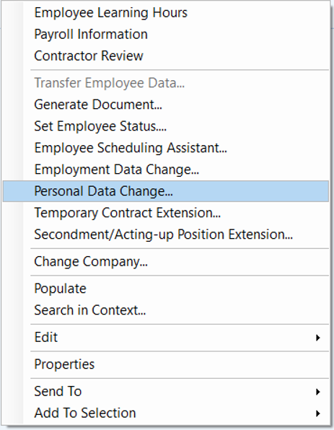

You will enter the Personal Data Change form.

A change reference number will be automatically created, and the request status will currently show as blank.
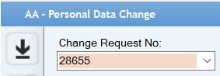

Each type of personal change is allocated a separate tab. Click on the tab that contains the details that you want to change.

The Current Data section is the information currently in the IFS contractor record.
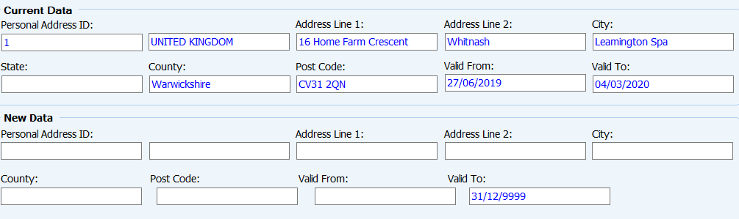
Enter the new information in the New Data section, ensuring that all fields are completed. Ensure that all information is entered correctly, ie, spelling and capitalisation, as this automatically populates the relevant fields in the IFS contractor record.
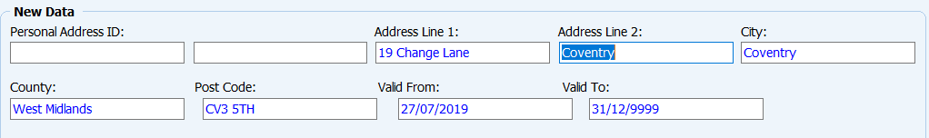
Unlike employment data changes where the effective date (‘Valid From’) must always be a Sunday, any Valid From date can be selected for any personal change. You will normally enter an effective date that has been indicated by the contractor.
If you are submitting a change of name (marriage, divorce, deed poll etc), take a copy of the proof of name change document, and sign & date the copy to confirm that you have seen the original. Attach this in the Documents box in Attachments, and it will be submitted as part of the change request.
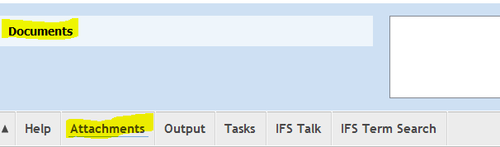
The proof of name change is required to update the valid right to work proof held on IFS for direct and PSC contractors. The proof of name change document is not required for an agency or service contractor.
Click on the Save icon .
Right click and select Send for Approval.
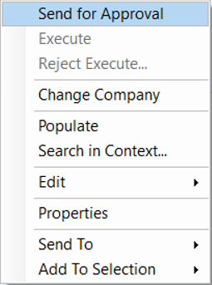
You will know that the request has been successfully submitted when the Status on the top row of the change form changes from blank to Pending Approval. You can check the status of the request at any time by selecting the Status tab.
Personal data changes do not require next level manager approval, so the request is automatically routed to the PSG Admin team for processing.

END OF PROCESS

Document Control

Document Version | 2.0
Process Owner | Aly Hull
Document Maintainer | Aly Hull
Date Last Updated | 05/12/2019
Last Updated By | Ali McCreery
Date Next Review | 05/12/2019
Document Location | Available on colleagues connect, with master held on B drive > PSG > PSG Shared Area > Resourcing > Contractors > IFS Contractors Project

END OF DOCUMENT

