**Service Contractor Engagement Process**

**Society Contractor Policy**

All contractors must be onboarded and managed using the Society Contractor Management Processes.

No contractor can be engaged, extended or terminated without following these processes.

Active Directory (AD) accounts are auto managed by the creation and accurate maintenance of the IFS contractor record, which enables AD account creation, extension, disabling and deletion.

**Contractor Types**

Always check the contractor type so you know what process to follow, what information is required and what checks to make.

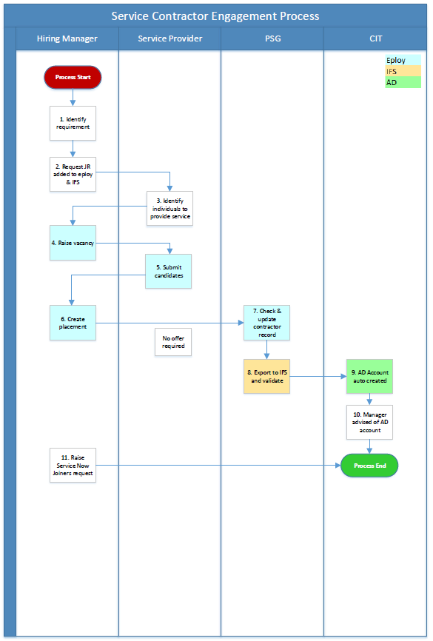

**Process Overview**

The Service Contractor Engagement process enables the onboarding of service contractors in a manner compliant with the Society’s contractor management policy.

This process applies to the onboarding of service contractors.

The Service Contractor Engagement process is to be used when you have an individual that requires access to the Society’s IT systems as part of the service provided by their company.

Finance governance approval would have already been obtained as part of initially engaging the service provider or subsequent contract extensions.

Procurement should already have been engaged by this point, ie, the Third Party Supplier (TPS) contract set up and signed off by the Society and the company providing the service.

Refer to the Contractor Management right to work guidance and the data elements table to be clear on the different data and document requirements that each contractor type has.

**Manager Process Steps**

**1. Identify requirement**

You have identified a requirement for resource and have decided that a contractor is the best way to fill the vacancy.

**2. Request JR added to eploy & IFS**

To be able to progress a new contractor engagement, check first that the job role exists in eploy to be able raise the vacancy. You can do this by viewing the available job role templates in eploy when first creating a vacancy.

If the job role does not exist, then a role profile will need to be written so this and the job role can be added to eploy and IFS. Contact the Society resourcing team via [hiringmanagersupport@midcounties.coop](mailto:hiringmanagersupport@midcounties.coop) for guidance on how to do this.

**4. Raise vacancy**

Log into eploy and click on Create from Template.



You will be asked to specify whether your vacancy is a contractor role or not.

Always click Yes for a contractor role.

***Important*** *If you are raising an employee vacancy (ie, you want to employ an individual on a fixed term or permanent contract), please do NOT click Yes to the ‘Is this a contractor role’ question. If you do this can cause significant issues with the employee exporting to the IFS system as a contractor, and can cause delays with starting and potentially payments.*

Click SELECT, next to *Load From Template 

This will load a drop-down list of all the vacancy templates that you will have access to.

Click on the vacancy template that you need, then click Continue.

The vacancy template will load in full. Please review the information that has populated before proceeding.

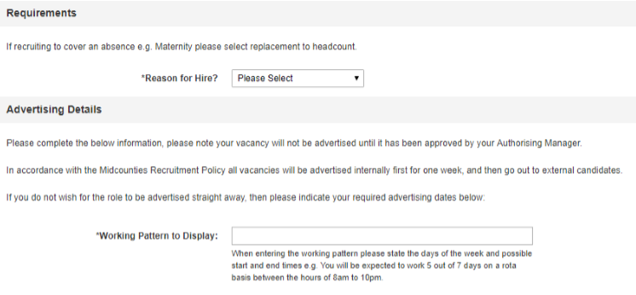

Click on the dropdown list next to Reason for Hire and select the relevant option. If you are raising a vacancy to replace a colleague, you must state their name.

You will also need to enter the working pattern in Working Pattern to Display.

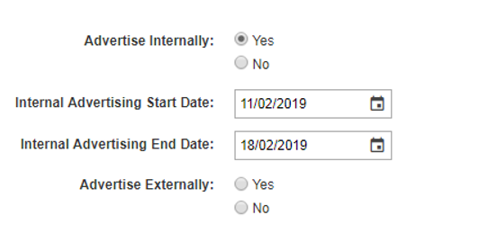

Click Yes next to Advertise Internally and enter the advertising dates that you would like your vacancy to go live for.

Repeat this step for Advertise Externally.

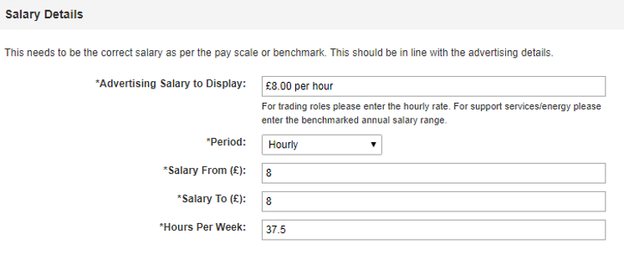

In Advertising Salary to Display, enter the salary you want to advertise for your role, e.g. “£8.00 per hour”. Please ensure the pound sign, ‘£’, is included when you enter this information.

Click on the dropdown list beside Period – select Daily for self-employed contractors, and select Hourly for those contractors that are hourly paid / charged for.

The Salary From and Salary To are ranges for your salary. If your salary has no range, enter the same figure into both fields. If your salary does have a range, enter the lower figure into Salary From and the highest figure into Salary To.

Enter the weekly hours for your role into Hours Per Week.

*As the role is for a contractor, you may not know the pay rate at this stage. If this is the case, then Advertising Salary to Display can be entered as ‘To be agreed’ and Salary From and To can be entered as 0.*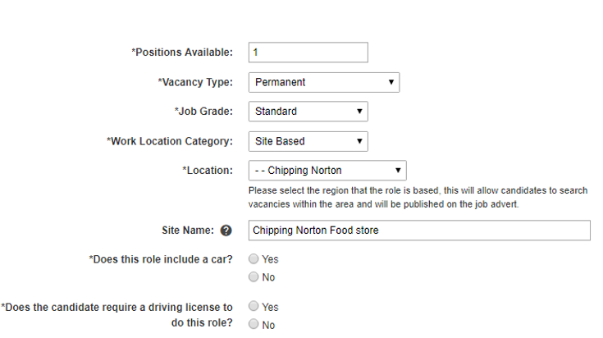

Complete Positions Available with the number of positions you are advertising for.

***Important*** *Select Contractor in Vacancy Type.*

You will need to state the length of the contract duration, in weeks.

Repeat the same step for Job Grade and Work Location Category

Location will feed into the vacancy advertisement. Click the dropdown list and select the town/city your where your site is based.

If you site is located in an area with several other Midcounties branches or if you would like to specify the name of your location, you can enter the name of your store into the Site Name field e.g. “Cowley Road Food store”.

If your role requires the use of a car, click Yes, this will bring up the Estimated annual mileage which you will need to provide using the dropdown list.

If you candidate needs a driving licence for the role, click Yes.

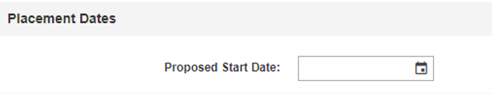

Enter a Proposed Start Date if you have a provisional start date in mind for this vacancy. This is not a mandatory field so leave blank if you do not have a date to enter.

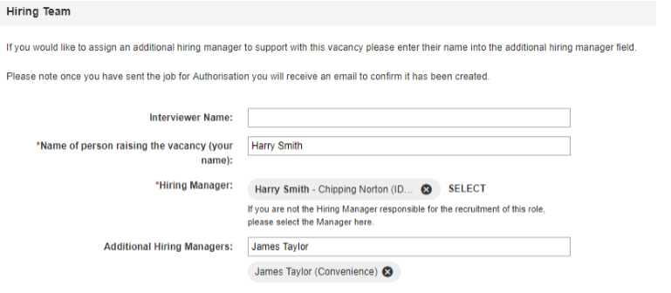

Enter the Interviewer Name, this can be you as the manager or if someone else is interviewing candidates on your behalf, enter their name here.

If you are raising the vacancy on behalf of someone else, remove your name next to Hiring

Manager by clicking on the  and click SELECT to search the name of the relevant manager. Click on the name when you have located them.

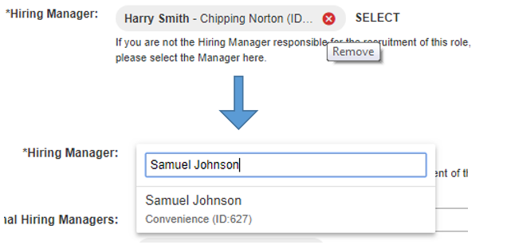

If another manager is assisting you with the recruitment for this vacancy, enter their name into the Additional Hiring Managers and click on the name when it populates; you can add more than one manager.

Confirm whether the role has been approved by Finance Governance by selecting the relevant option from the FGC approval obtained dropdown.

If yes, provide the FGC Capex Number. If No, state the reason why.

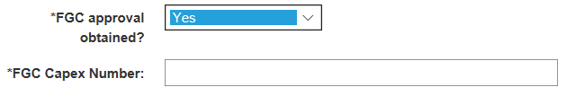

Click Continue to proceed or Save As Draft if you are not proceeding for now.

You will be redirected to a page where you can select who will authorise our vacancy.

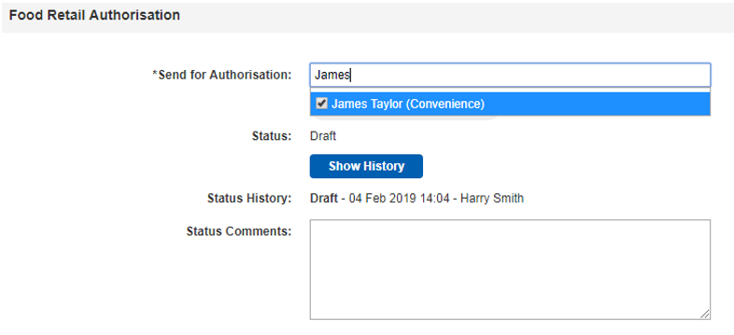

Enter your authorising manager’s name into the Send for Authorisation field and click their name when it populates. In most cases, this will be your line manager; if your line manager is away, please select an alternative manager.

You can always add a comment in Status Comments if you wish to provide any further information.

Click Send for Authorisation when you are happy with your vacancy information.



Your authorising manager will be notified by email that there is a vacancy for them to authorise. You will be notified by email as to whether your vacancy has been approved or not. If approved, your vacancy will now be with your Personnel Administrator, who will check the vacancy and set it to live.

**5. Submit Candidates**

The service provider should have already identified at this point the names of the individuals that require AD accounts. As manager, just go the Midcounties Careers website at <https://www.midcountiescareers.co.uk/>, and find your vacancy by using the search boxes. Then click on the  button and copy and paste the web address into a mail – the format will be similar to <https://www.midcountiescareers.co.uk/vacancies/6827/hr-advisor.html>

Then send to the service provider for them to register and apply for each individual that requires an AD account.

**6. Create Placement**

Once the service provider has applied for all individuals requiring an AD account, your candidate summary in eploy will change to show a number beside All Applications / To Review which is where your contractor/s would be sitting.

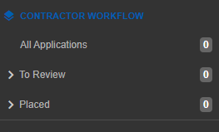

Click on the contractor’s name to start creating the placement.

When placing a contractor to your vacancy, you will be required to complete several different pieces of information compared to a new employee starter.

Ensure that you have uploaded the contractor’s right to work if applicable, depending on the contractor type. Refer to the Right to Work guidance on the Contractor Management guidance on Colleagues Connect.

Click Create Placement Now.



The placement screen will load with the basic information regarding your contractor vacancy.

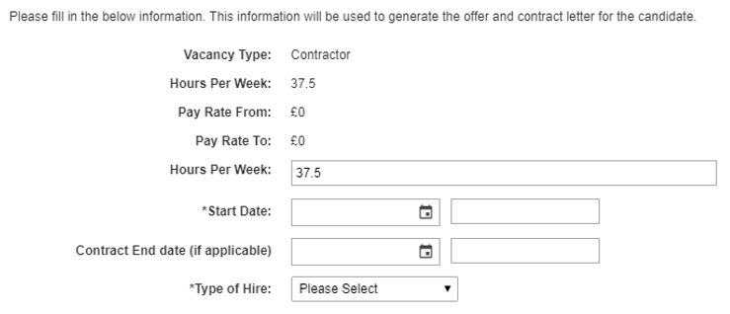

Complete the Start Date and End Date.

Select the appropriate Contractor Type of Hire. If you are unsure of the contractor type, refer to the contractor definitions in the Contractor Management guidance on Colleagues Connect.

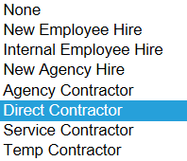

Your page will alter with extra information that you will need to complete.

Enter the Daily Salary.



Confirm whether an AD Account is required or not.



***Important*** *This will automatically create your contractor’s AD account after the IFS contractor record is created following successful placement, offer acceptance and export to IFS.*

Provide the Cost Centre and Right to Work details.

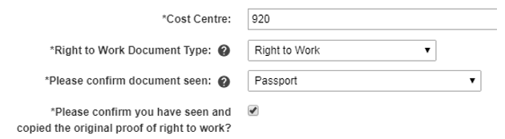

The following are **not** applicable for service contractors.

* VAT Registration Number check
* Company Registration Number verification
* Employment Status Questionnaire
* Childcare Request for Temporary Agency Cover
* Proof of Insurance

Review your placement information and click Continue, then Send to HR.

Your placement will go through to your Personnel Administrator.

***Important*** *The steps from placement to export to IFS are significantly reduced for service contractors. No contract, policies or onboarding information is required, so your Personal Administrator will fastrack the contractor record from Placement direct to Contract Checked – Ready to Export.*

**11. Raise Service Now Joiners request**

IFS contractor record creation automatically creates a disabled AD account, and the Joiners Movers Leavers (JML) process then enables the created AD account.

***END OF PROCESS***

**Document Control**

|  |  |
| --- | --- |
| **Document Version** | 2.0 |
| **Process Owner** | Aly Hull |
| **Document Maintainer** | Aly Hull |
| **Date Last Updated** | 05/12/2019 |
| **Last Updated By** | Ali McCreery |
| **Date Next Review** | 05/12/2020 |
| **Document Location** | Available on colleagues connect, with master held on B drive > PSG > PSG Shared Area > Resourcing > Contractors > IFS Contractors Project |

***END OF DOCUMENT***