**HMRC CEST guidance for Travel PTA Division**

One of the key ways that the Society mitigates employment law and tax risks is by establishing the contractor’s employment status.  By making this assessment, you are then able to determine whether to engage and if so under what circumstances.  Note that for agency, temp and service contractors, the individual is employed by a separate company, and so no employment status check is required – the employment status check only applies to direct contractors, ie, self-employed and Personal Service Company (PSC) contractors.

Go to the HMRC CEST system via the below link – CEST stands for Check Employment Status for Tax.  The questions will assist you in understanding whether the contractor is self-employed or could be deemed an employee under the terms of the proposed engagement.

<https://www.tax.service.gov.uk/check-employment-status-for-tax/reason-for-using-tool>

You can also refer to the HMRC guidance on checking and understanding employment status.

<https://www.gov.uk/guidance/check-employment-status-for-tax>

Go to the HMRC CEST tool.

For the first question ‘Which of these describes you best?’, enter ‘the end client’.

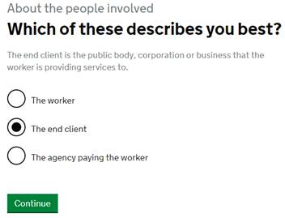

Answer the questions as prompted – it should take you no more than a few minutes to complete.

You will receive an automated result once you have completed all questions.

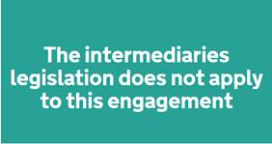

If the result is ‘intermediaries legislation does not apply to this engagement’, then you can engage the contractor as a self-employed contractor.

If the result is ‘intermediaries legislation does apply to this engagement’, then the contractor may be deemed to have an employee status.  To continue to engage as a self-employed contractor, review the terms of the engagement and ensure that the contract reflects any changes that mitigate any employment law and / or tax risks.

If you are in any doubt about the questions, answers, result or what to do next, please contact the Society Tax Manager.

Copy and paste the result **including the questions and answers** below the results box, into a word document. Sign and date the front page to confirm when the check was done by and by whom.

Save the document as CEST Results [today’s date] and upload to eploy as part of placement actions.

Once you have completed the employment status assessment or have deemed it not applicable, proceed with placement …