Content | Information | Notes
This brief is a guide, and for you to cover at the level of detail you feel is needed for your Teams -. | Resources –  PowerPoint and Briefing notes  Conversation scripts  One-page benefits  Abbreviations –  SOTP – Share of the Profits  AGM- Annual General Meeting
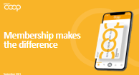 | Aim- Introduction | Thank you for attending today’s brief, this should take around 20 minutes.  The aim of today’s brief is to talk to you about our membership, the Your Co-op members App, the conversations you could be having with your customers and members, and help develop your confidence, and communication skills when talking to our customers and members.
 | Membership makes the difference | Membership makes the difference, for you, your community and your world
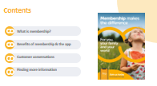 | Talk through the objectives. | We will go through -  - What is membership  - Benefits of membership and Your Co-op members App  - How and different types of conversations to be having  - Where to find more information
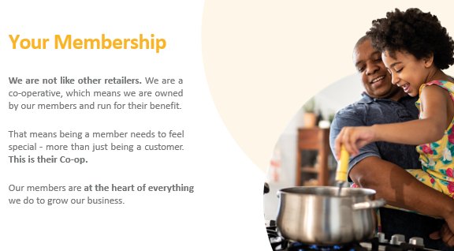 | Your Membership  Recap - Midcounties | Midcounties is a consumer Co-operative owned and controlled by its members. We are part of the global Co-operative movement and subscribe to Co-operative values and principles that govern all Co- operatives around the world. ​  ​  Our purpose is simple but ambitious with Co-operative values at its heart – what we do with our profits -  - We share with our members  - Invest back into our local communities  - Invest back into our business. ​  ​  We are not like other retailers. We are a Co-operative – which means we are owned by our members and run for their benefit. ​  And that means being a member needs to feel special – more than just being a customer. This is their Co-op.​  Our members are at the heart of everything we do to grow our businesses. ​  ​  Why do we need members​?  Members Trade with us which in turns makes us profit​  Members take an Interest in our other Trading Areas promote and shop with us​  Members can share their views through AGM/ member conversations and half yearly meetings​  Members campaign with us​  Members become our ambassadors, promote others to trade with us​  Members play an active role in our Society​  Let’s take a look at our membership benefits and what it has to offer and what it means for our member’s ​
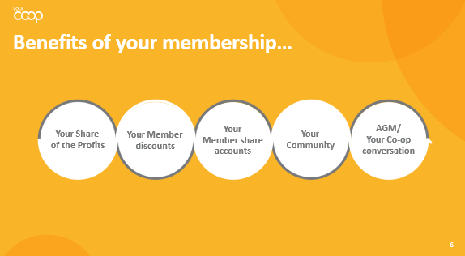 | Membership makes a difference | Benefits of Membership ​ see how membership makes a difference  Share of the profits​ which means -  We reward our members by sharing our profits with them the value is dependent on the profit made​, making our members feel valued for the everyday ways they spend with us, the more they spend within our family of business groups the more they will benefit from membership. colleagues should talk and promote membership during each transaction. ​  ​  Members can choose to use their share to spend in any of our business groups, pay it into their share account, or donate to charity​ for example credit their energy or phone bill, redeem in our Food, Childcare, Travel and online Pharmacy, or pay into their share account and withdraw when needed.  ​  Member exclusive discounts - which means! Value  Our members in some of our Food stores have – 10% discount known as Diamond discount 60 plus, (the member should ask for the discount) mem  In Travel members receive great rates and better exchange on Travel money. ​  ​  In Healthcare (online) our members receive 10% discount on all non-prescription items as well as a member’s rate for the online DR service giving members peace of mind when travelling abroad​.  ​  Share Accounts - which means our members are shareholders, they can invest in and earn interest on balances over £10, invest a maximum of £100,000., it’s easy to sign up they simply call the share ledger team at Head Office, 0800 435 902 (select option 4), and they’ll do the rest!​  https://www.midcounties.coop/membership/member-investments/share-account/ ​  We believe in the value of supporting the communities where we trade and getting Involved​ which means  Members can apply for grant schemes for their local communities £250, these grants are available throughout the year. ​  ​  Members take part in for example, litter picking, donating to our Food banks, being part of our regional communities, members and colleagues working together to support their local community, local charities and volunteering together to help build strong local communities. this is a great way to give back to our members and customers. ​  ​  Annual General Meeting which means members are invited to actively have a say on how the business is run, explain what they want, an opportunity for them to have a vote on key decisions for their Society, find out more how we are performing (unlike many businesses).  We also have Half yearly meetings and member conversations are other ways members can actively get involved with us​ another great opportunity to have their questions answered by the Executives of the business groups, Phil Ponsonby our CEO meet our business senior teams, our fantastic local suppliers to the Young Co-operators within Midcounties a great chance to learn about them and members to ask their own questions. ​  An example of the recent vote on members voted for -the SOTP to be digitalised this was put to the members at out half-yearly meetings, and they voted in favour of it. this is a great example of how our members have a say in how we run. ​  Remember Midcounties is democratically controlled by its members and owned by its members, we are not a PLC we are owned by members​,  we make changes for the better, guided by our values and principals​.  ​
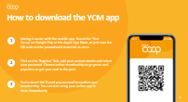 | How to download the App | Easy access to membership Via the Your Co-op members App easy for customers and members to signs up
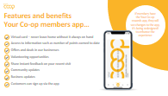 | Features and Benefits of the Your Co-op members App  Talk through the features and benefits for the Your- Co-op members App and why customers and members should download the App | Easy access to membership –  - Virtual card – never leave home without it always on hand​  - Access to information such as number of points earned to date​  - Offers and deals in our businesses​  - Volunteering opportunities​  - Share instant feedback on your recent visit​  - Community updates​  - Business updates​  - Customers can sign up via the App​  If members already have the Your Co-op rewards app, they will see changes to the App, it is all being redesigned, to make it easier for our members
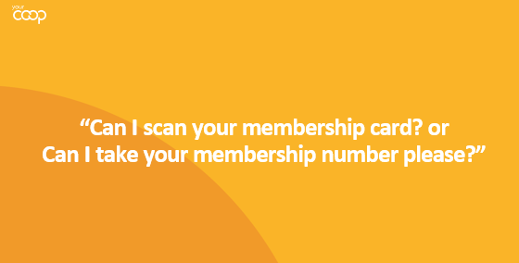 | Treat every customer as a potential member. | Teat every customer as a potential member. Make them feel they are missing out.  Customer facing roles -  Every customer should be prompted for their membership card and number encourage our customers to become members and members to cross trade with us.  Management roles –  Ensure your teams are having these conversations we want to increase our membership to have  Wider range and access to membership  Increase our membership  Trade more with our businesses
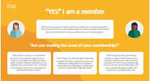 | Customer is a member – conversation  All colleagues must ask the customer for their membership card or number | Remember practice makes perfect as long as we ask all our customers for their membership card or number, you can reply with what comes more naturally to you!  “Did you know, we are a family of businesses where you can also earn points?” ​  ​  “Do you have the Your Coop Members App? it’s easy to download which means your virtual card to hand you never miss out on earning points” ​  “Did you know that you can download the Your Co-op Members App, and have access to your digital card view our latest offers, business updates, feedback on your experience of your recent visit, and much more”  “All the information to hand” ​  “Don’t forget as a member you have member benefits, as well as other deals, such as member currency rates with our Travel business, download the Your Coop members App, where you can find all the information, even some volunteering opportunities”  “Don’t forget can also earn points by being, ​  involved and have a say in how we run our business by taking part in our member's conversations and attending our AGM, book via Your Co-op members App take a look”  Remember practice makes perfect as long as we ask all our customers for their membership card or number, you can reply with what comes more natural to you! ​
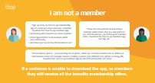 | Customer is not a member-  Share some of the conversations  Support and coach colleagues to overcome some of the objection | All colleagues must ask the customer for their membership card or number -  “Sign up today via the Your Coop membership App, it’s quick and easy to become a member, by downloading the App”  “By becoming a member, you will earn points towards our Share of the profits”  “As a member you’ll have great opportunities to be involved within your community”  “You get to have a say on how the business is run, when you become a member”  “There are many benefits in becoming a member which means that you earn points in our other businesses, you’ll have great member offers, download the Your Co-op Members app, and sign up today”  “You’ve already spent £.... you’re missing out on points, which you can later redeem here or within our other business areas for example towards a holiday, or towards your Childcare fees, phone or energy bill”  “Download the Your Coop members App, for more information”  “There are many benefits in becoming a member which means that you earn points in our other businesses also, you’ll have great member offers, download the Your coop members App, and sign up today”.  Tips  Don’t forget if the customer is in a hurry refer them to our website https://www.midcounties.coop/ or encourage them to download the App where they can sign up and find out more information about membership and how they can make the most of it  Some customers may seem to be in a hurry, have a quick conversation while you are processing their transaction.  If a customer is unable to download the App, or do not want too, may not have a smart phone as members they still receive all the benefits, membership offers.
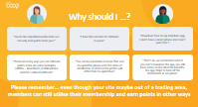 | Handling customers questions  Why Should I?  (Managers to role play) allow colleagues to have a go!  Practice | You may come across some questions, and may need to have some additional conversations with your members and non-members for example -  “You’re the only Midcounties near me, so I can only earn points with you”  “There are many ways members can still earn points, here are some examples, within our Utilities business if a member signs up to broadband, or even mobile phone contract, they earn points throughout their contract.”  Remember… even though a member may not have many Midcounties sites nearby, members can still make the most of their membership in other ways…  Members can trade and earn points through our Healthcare website, book a holiday with Travel, can be done online you don’t have to be in a Midcounties area this will help members and non-members see how membership can be meaningful for them.  “I have this card and it’s different to yours”  You can be a member of more than one Co-operative Society; however, you are missing out on points with us, as well as exclusive member offers and discounts, having a say in how Midcounties run”  I don’t have a smart phone or don’t want to download the App  If a customer/ member is unable to download the app or does not want too, reassure them, they still benefit from all membership benefits and offers.
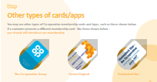 | Other types of cards colleagues may come across | We work closely with other Co-operatives for example Central England, The Co-operative Group and Chelmsford Star where we have partnered enabling members and colleagues to earn points and discounts.  If a customer presents a different membership card/ number, you can still  Customer Member (non Midcounties) scan or enter the membership number they will earn membership points based on Midcounties rewards points system  Colleague Member (non Midcounties) – scan or enter the membership number, they will earn membership points based on Midcounties rewards points and receive their discount rate of the owning Co-operative in this case Midcounties  In summary  - Membership card/ number will work in the same way  - Earn membership points on purchases made with us as we can in these Co-operative outlets - (Central England Co-operative, Chelmsford Star Co-operative  - Points are converted into a dividend-based on profits accrued (points earned equivalent to the individual Co-operative rewards).  - As a colleague receive a discount rate of the owning Co-operative where the transaction was made.  Still introduce our membership and explain how they are missing out on Midcounties membership benefits, share some examples -  - Diamond discount, - 10% Diamond Day every Tuesday if 60 or over and a member will only apply in selected Co-op Midcounties Food stores.  - Great travel currency rates in Travel 10% Online Healthcare  - Attend our Annual general meeting – have a say, vote on key decisions.  - Half yearly – Your Coop conversations – meet the Executives, suppliers
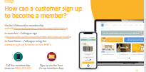 | Methods in which customers can sign up | There are several ways in which customers can sign up to become Midcounties members  - If you’re in Travel/ Childcare/ Utilities use the branch sign up site https://www.midcounties.coop/membership/signup/1nst0re/? This should be the site all sites use. It does require an email address. If customer has no email, they are asked to use option 3. see below.  - Customers can download the Your Co-op members App and sign up  - Customers can also sign up from home via our website they will need to verify their email details and set up a password. https://www.midcounties.coop/membership/signup/  - If the customer does not have an email address, they can call membership team, on 0800 435 902 and the membership team can sign them up.  Some Food stores also have the option to sign up through QR codes from the customers receipts and also colleagues can sign customers up with the handheld terminals
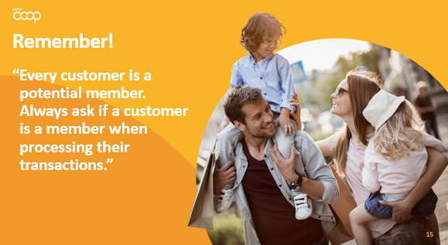 | Every customer is a potential member summarise the briefing | Every customer is a potential member, always ask if a customer is a member when processing their transactions  Recap – Why wouldn’t they want to be part of our amazing business  - Members can sign up via the Your Co-op members App, and have access to all information regarding their membership and Midcounties  - Membership is important because our members run the society, this allows them to have a voice vote say on their business  - Earn points which vary to our business groups  - Members trade with us and take an interest in our business area’s  - Members can campaign with us
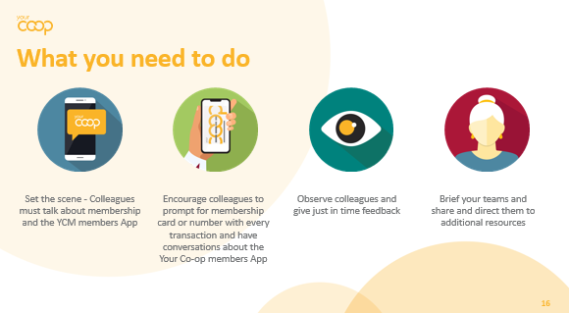 | What you need to do next | If you are the briefing manager, these are next steps you need to take-Membership is a key part of our strategy, and we all need to ensure we play our part if you are a manager  - Encourage your teams to talk and promote membership and the Your Co-op members App  - Ensure all customers are prompted for a membership card or number, then continue the conversation based on response  - Observe and talk to your teams where they have promoted membership really well, also share some conversation tips about membership & the Your Co-op members App.  - Ensure all teams are fully briefed and understand the benefits of membership, and the features of the Your Co-op members App
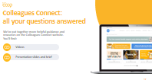 | Where you can find more information | Colleagues Connect; All your questions answered.  We have put together more helpful guidance together on Colleagues Connect, where you will find the resources, for example  - Video-  - The presentation slides and accompanying Brief, to be able to brief your teams in the most effective ways.
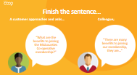 | Finish the sentence… | Manager to ask the question, ask colleagues to finish the sentence…  A customer approaches and asks, “What are the benefits of becoming a member of the Midcounties Co-operative”.  *Manager to pause and wait for colleagues to respond with their answers*  There are many benefits to joining the Midcounties Co-operative.  Some examples are:  - Your Co-op members App all the information to hand  - Our members own Midcounties Co-op, meaning we run for their benefit and put them at the heart of everything we do.  - Earn points towards Share of the Profits, every time they trade with Midcounties. Which are converted into vouchers yearly. (Pay out depending on profit and points earned)  - Have your say- Vote on certain aspects of the business, i.e., who sits on the board of directors etc. Attend our Annual General Meeting  - Member exclusive discounts- currency rates in Travel, Diamond discount in food, 10% off online at Co-op Pharmacy.  - Give back to the community- apply for grants on behalf of your local community, donate to foodbanks and be involved in organised litter picks events.
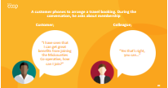 | Manager Finish the sentence… | Manager to ask the question, ask colleagues to finish the sentence…  A customer phones to arrange a travel booking. During the conversation, he asks about membership.  Customer: “I have seen that I can get great benefits from joining Midcounties Co-operative. How can I join?”  Colleague; “That’s right you can…”  *Manager to pause and wait for colleagues to respond with their answers*  Depending on business  Online by visiting: https://www.midcounties.coop/membership/signup/by phone 0800 435 902  Downloading the Your Co-op members App and signing up  Food – Handheld Terminals, selected sites have QR codes on their receipts.  Travel - Super Divi system  Utilities – website/ telephone  Healthcare – website  Funeral – Super Divi
 | Summary | Finish by summarising what we have covered  - Membership Your Co-op Members App  - Different types of conversations  - Roles and responsibilities  - Where to locate additional resources
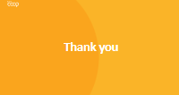 |  | Thank you for listening our ambition is to increase our membership thank you for supporting us with our journey and driving it forward.  •Wider range and access to membership  •Increase our membership  •Trade more with our businesses

