Contractor Termination Process

Society Contractor Policy
All contractors must be onboarded and managed using the Society Contractor Management Processes.
No contractor can be engaged, extended or terminated without following these processes.
Active Directory (AD) accounts are auto managed by the creation and accurate maintenance of the IFS contractor record, which enables AD account creation, extension, disabling and deletion.

Contractor Types
Always check the contractor type so you know what process to follow, what information is required and what checks to make.

Contractor to Employee Conversion
If you want to convert a contractor to an employee (FTC or permanent), follow the contractor termination process and then process the individual as a new starter through the new colleague process.
If the colleague still requires an AD account, a new AD account will be created.

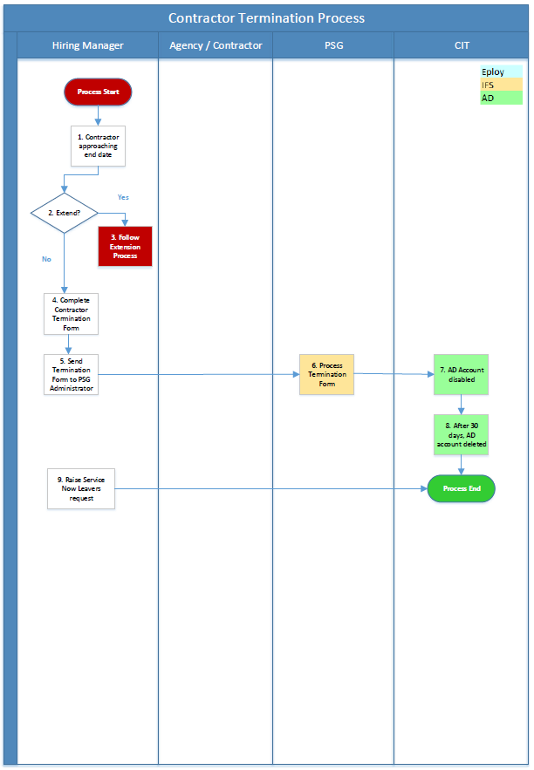

Process Overview
The Society’s contractor management process requires all contractors to be terminated from the IFS system before contract end date.
Once you have made the decision to terminate a contractor, follow the Contractor Termination Process.
The following guidance corresponds to the relevant process step in the process overview diagram.

Manager Process Steps

1. Contractor approaching end date
All contractors by their nature should have a contract end date. Engaging contractors on ‘open-ended’ contracts potentially exposes the Society to employment law risks. If you are unsure, refer the query to the Society’s tax and legal experts.
To view a contractor’s current end date, enter IFS and go to the contractor record.
Click on the Employment tab then the Periods tab, then view the End Date.
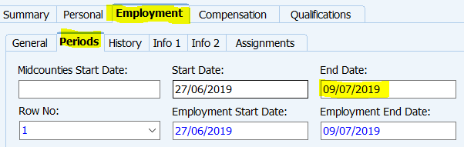
You will also receive automatic IFS email reminders as the contractor’s manager, reminding you of a contractor’s approaching end date. These reminders will be send 6 weeks before the current end date, 4 weeks before, 2 weeks before, 1 week before, 3 days before and on the day of the end date.
Your manager will also receive automatic IFS email reminders 3 days before your contractor’s current end date and on the day of the end date.
Important If your contractor has a current AD account, this will be automatically disabled if the contractor’s contract end date passes without extension. If the contract end date is still not extended 30 days after the account has been disabled, the account will automatically be deleted. The only way then to obtain a new AD account is to follow the full new contractor engagement process from the start.
2. Extend?
If you have made the decision to extend the contractor, follow the Contractor Extension Process instead.
4. Complete Contractor Termination Form
As soon as the contractor’s leaving date is known, submit the termination form.
You will find the current version of the termination form on the contractor page on Colleagues Connect in the Contractor Termination Process section.
There is no requirement to provide a reason for a contractor’s contract being terminated.
Your Personnel Administrator will select ‘Contractor’ as the Reason for Leaving when processing through IFS Leaver Assistant.
5. Send Termination Form to PSG Admin
Once the form is complete, email the termination form to your Personnel Administrator for processing.
As this is a contractor termination, it does not require emailing to your Payroll Administrator.
9. Raise Service Now Leaver request.
Follow the Leavers process on Service Now to remove assets and access rights from that individual.

END OF PROCESS

Document Control

Document Version | 2.0
Process Owner | Aly Hull
Document Maintainer | Aly Hull
Date Last Updated | 05/12/2019
Last Updated By | Ali McCreery
Date Next Review | 05/12/2020
Document Location | Available on colleagues connect, with master held on B drive > PSG > PSG Shared Area > Resourcing > Contractors > IFS Contractors Project

END OF DOCUMENT

