**Healthcare New Locum Process**

This document covers the process to follow when onboarding a new locum. A new locum is an individual who has not been engaged before and is not already on IFS.

For existing locums that have been engaged before and are on IFS, the weekly report on re-engagements that week is sent to Personnel Administration each Monday. The Personnel Administrator then adds the details of the re-engagement in the Assignments tab in the IFS contractor record.

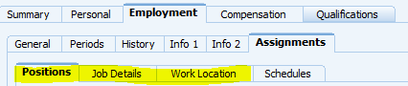

Note that the terms locum and contractor are used interchangeably – in this context they mean the same thing but for clarity, locum relates to the job role (Locum Pharmacist / Locum Dispenser) and contractor describes the resource type.

**Contractor Types**

Healthcare locums are generally what the Society would define as direct contractors, ie, the relationship is generally direct between the Society and the locum.

Direct contractors are deemed as highest risk by the Society as there is no intermediary such as an agency or other company involved. As such, locums need to be managed correctly through the onboarding process and managed ongoing via status reviews, extensions and terminations.

The focus of this document is onboarding only – status reviews, extensions and terminations are documented in the standard manager guidance for contractors, on colleagues connect.

<https://colleaguesconnect.midcounties.coop/how-to/contractors/>

Healthcare locum status reviews, extensions and terminations are handled by the IFS manager – in most cases this is the Healthcare Operations Support Manager.

**Supporting Information**

For additional details on contractors including systems and data elements, refer to the contractor management overview in the manager guidance for contractors on colleagues connect.

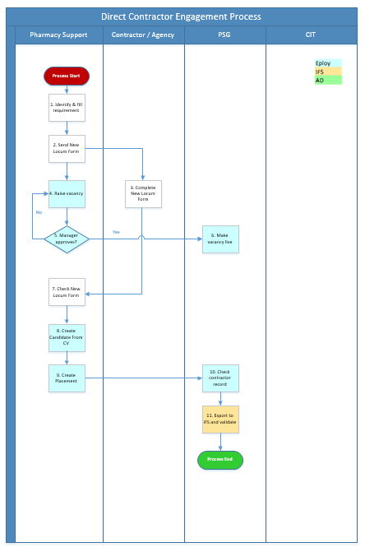

**New Locum Engagement Process**

**Process Overview**

The New Locum Engagement process enables the onboarding of healthcare contractors in a manner compliant with the Society’s contractor management policy. This process varies from the standard contractor onboarding in the following ways:

* Hiring manager actions are completed by Pharmacy Support rather than the manager.
* Pharmacy Support have core system user access rather than the normal hiring manager access. Pharmacy Support are only authorised to view, edit and manage locum vacancies, candidates and placements.
* Agency and locums do not register or apply directly via eploy. Instead they complete the New Locum Information Form, which Pharmacy Support then use to register and apply on the locum’s behalf.
* The interview stage has been removed from the healthcare new locum engagement process. Pharmacy Support move candidates from Application to Review direct to Contractor Offers To Do.
* The locum does not receive any offer, contract or policies via eploy. Instead, Personnel Administration move the contractor from ‘Contractor Offers To Do’ direct to ‘Contract Checked – Ready to Export’. This significantly speeds up the process - Pharmacy Support continue ensuring that the Locum Agreement of Service is completed by the locum.
* Key contractor documents are not managed through eploy due to the above variations from the standard process. Instead these are emailed to Personnel Administration to file on the IFS contractor record for ongoing reference and demonstration of compliance.
* Healthcare are allowed up to 5 working days from the contractor’s start date, to process the locum through application to offer (placement). This recognises Pharmacy Support’s imperative to keep branches open, both for commercial and NHS regulatory reasons.
* HMRC CEST assessment is not completed for every engagement. Instead this is done once for the Locum Pharmacist and once for the Locum Dispenser, as long as the terms of each engagement does not vary from the standard.

**Pharmacy Support Process Steps**

**1. Identify and fill requirement**

Fill the requirement for a locum in the normal way including updating Total Picture. Total Picture is the healthcare locum scheduling system.

**2. Send New Locum Form**

Email the New Locum Information Form to the locum. If the locum has been introduced by an agency, send the form to the agency to complete.

The locum / agency **must** type into the form rather than writing. This allows the eploy Create Candidate From CV function to work, and makes it easier to enter the information into eploy on their behalf.

**4. Raise vacancy**

Log into eploy and click on Create from Template.



You will be asked to specify whether your vacancy is a contractor role or not.



Always click Yes for a contractor role.

Click SELECT, next to *Load From Template 

This will load a drop-down list of all the vacancy templates that you will have access to.

Click on the vacancy template that you need, then click Continue.

The vacancy template will load in full. Please review the information that has populated before proceeding.

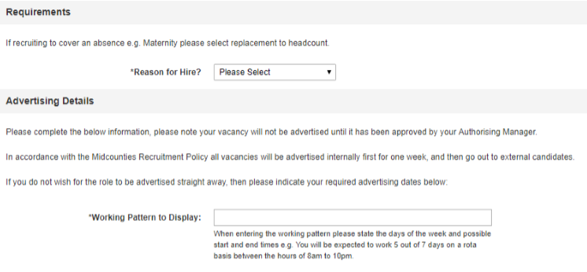

Click on the dropdown list next to Reason for Hire and select the relevant option. If you are raising a vacancy to replace a colleague or other contractor, you must state their name.

Working Pattern to Display is a system mandated field – for all locums enter ‘As required’.

As a candidate has already been identified and the locum registration and application is performed by Pharmacy Support, there is no requirement to advertise locum vacancies internally or externally. Ensure that the Advertise Internally and Advertise Externally fields are ticked No.



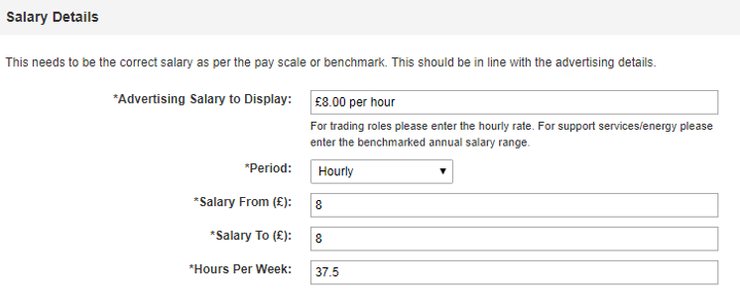

As the role is for a contractor, you may not know the exact pay rate at this stage. Advertising Salary to Display can be entered as ‘£13.00 per hour’ for Locum Dispensing Assistants and ‘£21.00 per hour’ for Locum Pharmacists.

Click on the dropdown list beside Period – select Daily for self-employed contractors, and select Hourly for those contractors that are hourly paid / charged for.

The Salary From and Salary To are ranges for your salary. If your salary has no range, enter the same figure into both fields. If your salary does have a range, enter the lower figure into Salary From and the highest figure into Salary To.

Enter the weekly hours for your role into Hours Per Week. This can be entered as 39 for locums.

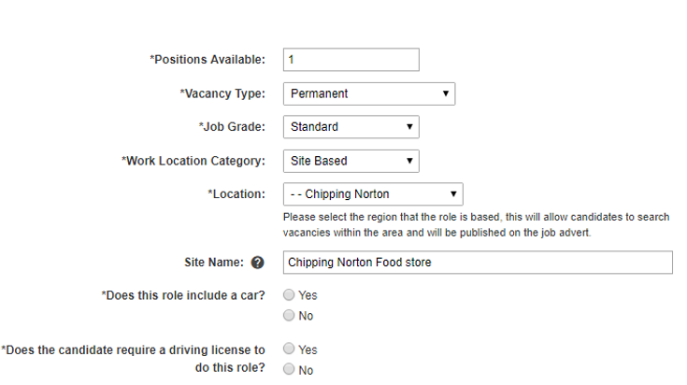

Complete Positions Available with the number of positions you are advertising for.

***Important*** *Select Contractor in Vacancy Type.*

Job Grade will be Standard and Work Location Category will be Site Based.

Location is the pharmacy location, eg, Lydney.

Site Name will be the pharmacy name, eg, Lydney Pharmacy.

Answer No to Does this role include a car?

Answer No to Does the candidate require a driving licence to do this role?

You will need to state the length of the contract duration, in weeks. Enter a standard 6 months for locums.

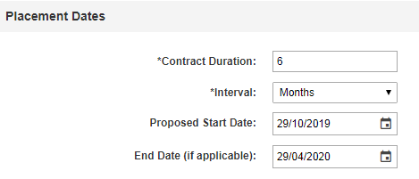

Enter a Proposed Start Date if you have a provisional start date in mind for this vacancy. This is not a mandatory field so leave blank if you do not have a date to enter.

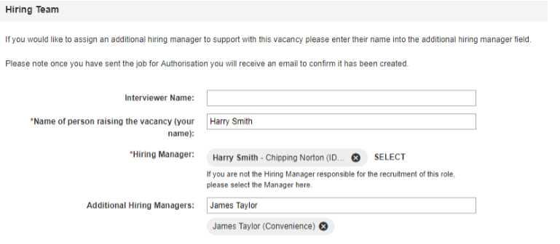

Leave Interviewer Name as blank.

Enter your name in Name of person raising the vacancy.

Enter the other Pharmacy Support name in Additional Hiring Managers. This allows that individual to also view and manage the vacancy as a hiring manager.

For FGC Approval obtained, enter Not Required.

Click  to proceed or Save As Draft if you are not proceeding for now.

You will be redirected to a page where you can select who will authorise your vacancy.

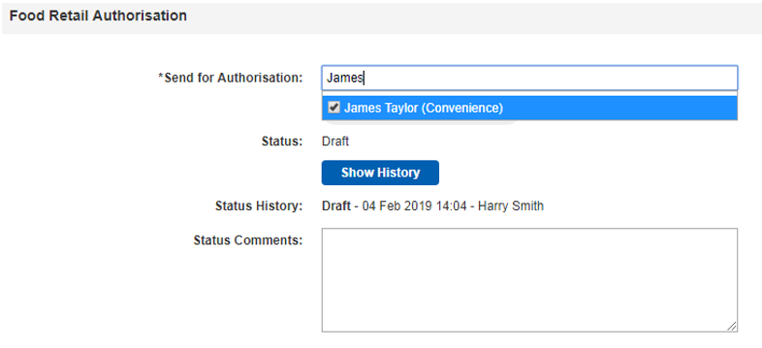

Enter your authorising manager’s name into the Send for Authorisation field and click their name when it populates. In most cases, this will be your line manager; if your line manager is away, please select an alternative manager.

You can always add a comment in Status Comments if you wish to provide any further information.

Click Send for Authorisation when you are happy with your vacancy information.



**5. Manager approves?**

Your authorising manager will be notified by email that there is a vacancy for them to authorise. You will be notified by email as to whether your vacancy has been approved or not. If approved, your vacancy will now be with your Personnel Administrator, who will check the vacancy and set it to live

**7. Check New Locum Form**

Review the New Locum Information Form, checking that all the relevant information has been provided, has been typed and contains no errors.

**8. Create Candidate From CV**

Find vacancy and start working on the vacancy. Click on  at the top right and you will see an orange bar appear below.



You can remove this bar at any time by clicking on the X on the far right of the orange bar.



You will see the following standard vacancy tabs.



Click on View, scroll to Candidate and select New Candidate from CV from the subfolder.



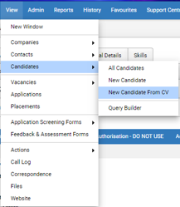

Choose the application form that has been returned, either by clicking on Select and selecting the document to upload, or by dragging and dropping the document as below.

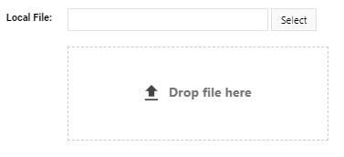

Leave the file settings unchanged.

Click  for eploy to set up the applicant.

A pop up will appear - you do not need to change any of the tick boxes - click to continue.

Once your candidate is created you will land on the personal tab of the candidate.



***Important*** *- Check that the information has exported by clicking on the Personal tab. This should match the Personal Information section on the New Locum Information Form.*

*Title will* ***not*** *automatically populate as it is a drop down field – select this manually.*

Once the candidate is exported in the top left (up by the new button) you will see a blue application button.



Click the Application button and move the candidate to the correct status by clicking on the yellow Website Application to Review button.

You will also need to enter into eploy the Contractor Specific Information on the New Locum Information Form.

Still in the candidate part of eploy, click on the Additional Details tab.



Complete the following fields under Additional Contract Details.

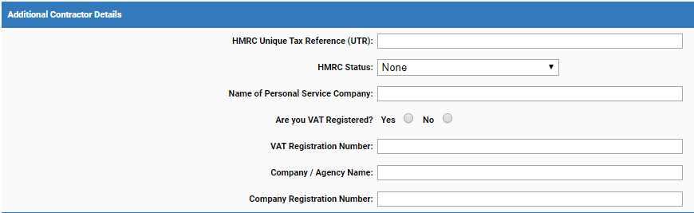

UTR is required for all direct contractors, ie, all locums. HMRC status is mandatory for all contractors so is required for all locums. Complete the other details or leave blank according to the information on the New Locum Information Form.

**9. Create Placement**

Now click on to your Hiring Manager portal link and logon. You will be presented with a default Vacancies summary screen.



Vacancies automatically filter on My Active Vacancies – select the relevant vacancy.

You will be presented with the vacancy detail – click on  and then select the candidate.

Click on the process button at the bottom right.



Move the candidate to the Placement status by clicking on the blue Placed button. The healthcare contractor workflow means that the interview stage is bypassed.



Click Create Placement Now.



The placement screen will load with the basic information regarding your contractor vacancy.

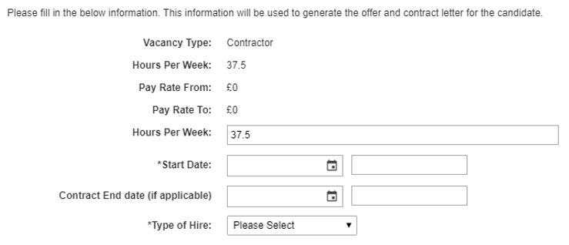

Complete the Start Date and End Date. Although locums may be re-engaged multiple times during a set period, the system contract duration for locums is 6 months, so the contract end date will always be 6 months from the start date.

Select the appropriate Contractor Type of Hire which for locums will always be Direct Contractor. Definitions of all contractor types can be found in the Contractor Management guidance on Colleagues Connect.

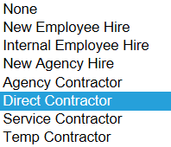

Your page will alter with extra information that you will need to complete.

Enter the Hourly Salary which will be the locum’s pay rate.



Select No to the AD Account Required question.



When placing a locum to your vacancy, you will be required to complete several different pieces of information compared to a new employee starter.

Ensure that you have uploaded a copy of the contractor’s right to work, signed and dated to confirm that you have seen the original. Refer to the Right to Work guidance on the Contractor Management guidance on Colleagues Connect. As most if not all locums are direct contractors, Pharmacy Support views the original right to work document/s, takes a copy, signs and dates the copy to confirm the original has been seen, then uploads to eploy as a Right to Work document.

Provide the Cost Centre and Right to Work details.

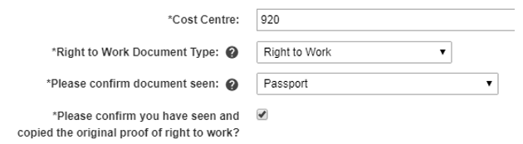

Select Not Required to Has VAT Registration Number been Verified?



Select Not Required to Has Company Registration Number been Verified?



If an Employment Status Questionnaire has been completed via the HMRC CEST tool, and whether this confirms the self-employment status of the contractor.



Upload the results of the Employment Status Questionnaire if the locum is self-employed or a PSC contractor. Refer to the Employment Status Assessment section at the end of this document for additional details.

Take the standard CEST results document, sign and date to confirm that there are no changes to the standard terms of engagement (ie, the answers to the questions are the same as the CEST results document), and upload.

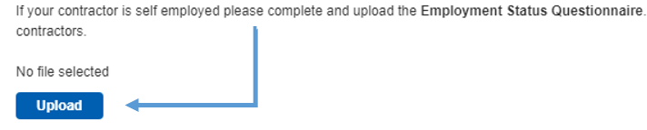

Select Not Required to the Has Childcare Request for Temporary Agency Cover Form been completed?



Confirm and upload Proof of Insurance if applicable.

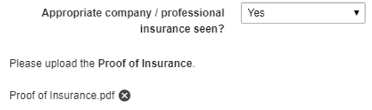

Review your placement information and click Continue, then Send to HR.

Your placement will go through to your Personnel Administrator for processing. For healthcare only, the Personnel Administrator will bypass the Your Offer stage in eploy, moving the placement from Contractor Offers To Do directly to Contract Checked – Ready to Export.

The contractor record then exports to IFS overnight to create a new IFS contractor record, and the Personnel Administrator then changes the eploy placement status to Candidate is now in IFS.

**Employment Status Assessment**

***Important*** *If you are looking to engage a contractor who has stated they are self-employed or under a Personal Service Company (PSC), you* ***must*** *complete an employment status assessment.*

The standard Society process requires an HMRC CEST assessment completed for every engagement. As this has already been completed for the Locum Pharmacist and Locum Dispenser, you need only check that the terms of the engagement do not vary from the standard for locums, then sign and date a copy of the HMRC CEST result, save the document as ‘CEST Results [today’s date] and upload the document to eploy.

The HMRC CEST tool will provide an automated result in response to the answers provided. Example below.



If the result is ‘**intermediaries legislation does not apply to this engagement**’, then you can engage the contractor as a self-employed contractor.

If the result is ‘**intermediaries legislation does apply to this engagement**’, then the contractor may be deemed to have an employee status.  To continue to engage as a self-employed contractor, review the terms of the engagement and ensure that the contract reflects any changes that mitigate any employment law and / or tax risks.

If you are in any doubt about the questions, answers, result or what to do next, please contact the Society Tax Manager.

Once you have completed the employment status assessment or have deemed it not applicable, proceed with placement …

***END OF PROCESS***

**Document Control**

|  |  |
| --- | --- |
| **Document Version** | 2.0 |
| **Process Owner** | Aly Hull |
| **Document Maintainer** | Aly Hull |
| **Date Last Updated** | 05/12/2019 |
| **Last Updated By** | Ali McCreery |
| **Date Next Review** | 05/12/2020 |
| **Document Location** | Available on colleagues connect, with master held on B drive > PSG > PSG Shared Area > Resourcing > Contractors > IFS Contractors Project |

***END OF DOCUMENT***