Contractor Status Review Process

Society Contractor Policy
All contractors must be onboarded and managed using the Society Contractor Management Processes.
No contractor can be engaged, extended or terminated without following these processes.
Active Directory (AD) accounts are auto managed by the creation and accurate maintenance of the IFS contractor record, which enables AD account creation, extension, disabling and deletion.

Contractor Types
Always check the contractor type so you know what process to follow, what information is required and what checks to make.

Process Overview
The Contractor Status Review is undertaken by the manager of the contractor status to confirm there have no major changes since contract start that could expose the Society in terms of employment law and tax.
The review is every 3 months and will usually take no more than a few minutes to complete. The review date in IFS is system calculated as 3 months from the original contract start, with further reviews required every 3 months after that. If the contract is less than 3 months, the review date will default to match the contract end date.

Potential Status Changes
These changes can include but are not limited to:-
- Terms and conditions, eg, pay and working hours.
- Scope of the engagement.
- Early termination due to work completed or other reasons.
- Pay rate the same as at contract start.
- Relationship between the Society and the contractor.
- That the IFS role still matches what the contractor is actually doing.
If the contractor has changed their own status, ie, started as a self employed contractor but then created their own company and started to bill as a Personal Service Company (PSC), or vice versa.

Manager Process Steps
If there are any major changes to the work that the contractor is doing, or there is a major change is the working / legal relationship with the contractor, raise this with the Society’s legal and tax experts.
If / once you are comfortable that there have been no major changes, the review can be marked as complete. This date then feeds through into PSG Data Warehouse (DW) to automatically update the contractor reports.
As the contract’s manager, you will receive automatic IFS emails, reminding you that action is required. These emails will be sent 2 weeks before the next status review date, 1 week before, on the day of the review, 3 days after and 1 week after the passed review date.

Completing a Status Review
Enter IFS.

Enter the IFS contractor record.

Right click anywhere on the contractor record.

Select Contractor Review.

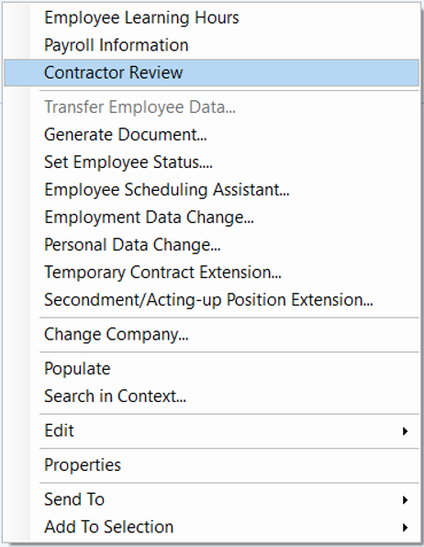

This will take you into the Contractor Review form, where you will be able to view any upcoming status review dates.

When the next status review is approaching, review the contractor engagement against the potential status changes list. You may also want to refer to the contractor extension criteria.
If nothing has changed, then enter today’s date under Actual Date, Unchanged under Contract Status and Completed under Status, and no further action is required.
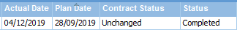
If there have been changes to the engagement which you feel could expose the Society in terms of employment law and tax, then enter Changed in the Contract Status column.
Contact the Society’s legal and tax experts. for further guidance and then take appropriate action. If the advice is that the engagement has not fundamentally changed, then amend the Contract Status to Unchanged.

END OF PROCESS

Document Control

Document Version | 2.0
Process Owner | Aly Hull
Document Maintainer | Aly Hull
Date Last Updated | 05/12/2019
Last Updated By | Ali McCreery
Date Next Review | 05/12/2020
Document Location | Available on colleagues connect, with master held on B drive > PSG > PSG Shared Area > Resourcing > Contractors > IFS Contractors Project

END OF DOCUMENT

