**FastPass User Guide – Permanent Colleagues**

**Overview:**

FastPass allows you to change your Windows password and/or unlock your account

**Accessing FastPass:**

The suggested method of accessing FastPass is from the quick links section on the Colleague Connect Homepage

Once loaded you will be presented with the Home Screen as shown:

***Note that colleagues on a permanent contract will be enrolled automatically so the Enroll feature is not needed***

To reset password or unlock account click on “Having problems with a computer login as shown:

Enter username (long version) and select domain from the drop-down list, enter security code as shown:

From the next screen select the option which is appropriate to the situation:

**1. Resetting Password**

If you have forgotten your password or are setting it for the first time, select:

Then select:

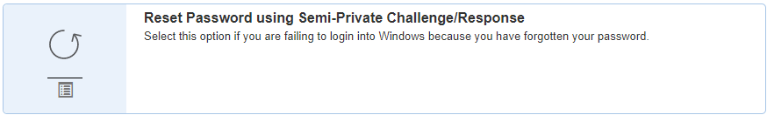

You will then need to provide the following information as shown:

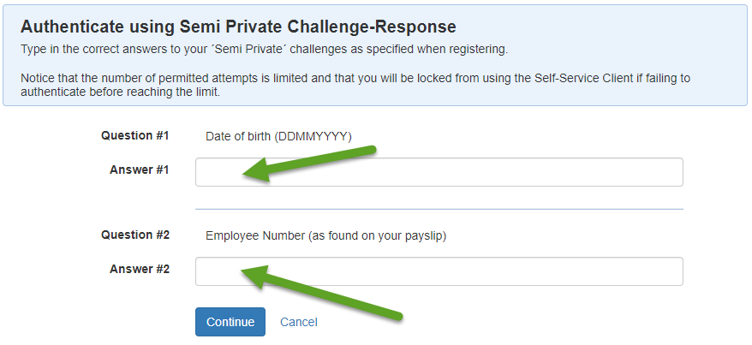

Once done follow the instructions on the screen as shown below to set a new password. Pay careful attention to the criteria shown in red:

If the password matches the required criteria, you will see the screen below. At this point click the “continue” button

After clicking the “continue” button you should be presented with confirmation that the password has been reset:

**2. Unlocking Account**

Once logged into FastPass select Unlock account:

Then click on:

Answer the questions as shown and click the “Continue” button:

You should then see confirmation that the account has been unlocked as below:

END OF GUIDE