Risk Assessment for ________________________

Hazard – Young Person at Work
The Health & Safety (Young Persons) Regulations 1997 place extra duties on Employers to ensure that young persons are protected in the workplace.

Possible Injuries – range of hazards face all colleagues during work – manual handling, repetitive work injuries, slips, trips & falls – the possibility of such an injury occurring with a young person increases due to their inexperience and immaturity

Who might be affected – young persons at work, also those around them who may be affected by the young person’s actions in particular, regarding fire safety, as a young person is not authorised to use any equipment or act as Fire Marshal / warden.

Controls in place –
- Young persons only allowed to work restricted hours
- Young persons not allowed to engage in strenuous manual handling – should not be involved in movement of full or heavy or large items
- No involvement in tasks that require special training
- No involvement in tasks that involve the use of dangerous machinery
- No involvement in cash operations
- Not authorised to act as Fire Marshal / Warden
- Not authorised to use any fire fighting equipment.
- Society and Branch induction to give young person greater knowledge of working environment
- Experienced “Minder” will be assigned to young person who will help them in their tasks and give guidance.
- Young persons given extra training compared to adults due to lack of experience
- Other colleagues informed of restrictions on work activities of young persons
- No imposed work rate given for tasks
Site specific controls as identified by manager –

Environmental Factors – unlikely to affect tasks but where environmental factors do affect work activities then specific guidance will be given to Young Person

Information & Training – All colleagues given Society & Branch induction.
Specific training given for each work activity that individual is involved in. Branch specific information available for manual handling and slips, trips & falls

Additional controls required – ongoing monitoring by Site Management

Residual Hazard –

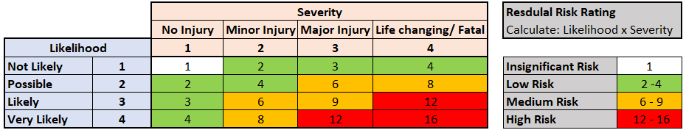

Risk Rating =

Records – To be held in Colleague Training records

Monitor & Review – Assessment to be reviewed after an initial period of 3 months and thereafter annually. Also, where activity changes substantially or following any accidents that may occur.

Comments – Residual risk considered to be low.

Name | Job Title
Assessment completed by:
Date:

Parental Approval Form

Young Person’s name:

Parent or Guardian’s details

Name:

Relationship to Young Person:

Contact details in case of emergency:

Working times

The days and hours to be worked by the Young Person and breaks to be taken are listed below:

Risks identified

The following key risks and associated controls have been identified by the site manager during the risk assessment.

Specific activities

The following tasks and activities have been identified as high risk for Young Persons and so will not be undertaken

Parental approval

I/We are aware of the activities involved and risks associated with these tasks and give our approval.

Name: Date:

Signature

