Society Water Hygiene
Written Scheme

Sept 2022

Society Water Hygiene Written Scheme – All Sites
Contents Page
Section 1 Introduction and Overview of Legionella 2
Section 2 Written Scheme Coverage:
- Management Arrangements 3
- Activities & Responsibilities 5
- Site Method Statement & Emergency Guidance 6

Section 3 Appendix 1 - Glossary of Key Terms 10
Appendix 2 - Extract from HSG274 Part 2, Checklist 11
Appendix 3 - Example of site schematic 14
Appendix 4 - Extracts from HSG274 Part 2, Legionella sample levels 15
Appendix 5 - References 16
Appendix 6 – Temperature Probe Calibration 17

Section 1
Introduction
This document forms the written scheme for All sites in Midcounties Co-operative (hereby referred to as “the Society”) properties.
Additionally, a Policy and Risk assessment can be found on the Society’s Intranet.
Legal Requirement
The Approved Code of Practice L8 (Fourth edition) gives practical advice on how to comply with the law; on the requirements of the Health and Safety at Work Act 1974 (HASAWA) and the Control of Substances Hazardous to Health Regulations (COSHH) concerning the risk from exposure to legionella bacteria. In particular it gives guidance on Sections 2, 3, 4 and 6 (as amended by the Consumer Protection Act 1987) of HASAWA, and Regulations 6, 7, 8, 9 and 12 of COSHH. The Code also gives guidance on compliance with the relevant parts of the Management of Health and Safety at Work Regulations 1999 (MHSWR).
Natural History of the Legionella Bacterium
Legionella bacteria are common and can be found naturally in environmental water sources such as rivers, lakes and reservoirs, usually in low numbers. Legionella bacteria can survive under a wide variety of environmental conditions and have been found in water at temperatures between 6°C and 60°C. Water temperatures in the range 20°C to 45°C seem to favour growth. The organisms do not appear to multiply below 20°C and will not survive above 60°C. They may, however, remain dormant in cool water and multiply only when water temperatures reach a suitable level. Temperatures may also influence virulence; legionella bacteria held at 37°C have greater virulence than the same legionella bacteria kept at a temperature below 25°C.
Legionella bacteria also require a supply of nutrients to multiply. Sources can include, for example, commonly encountered organisms within the water system itself such as algae, amoebae and other bacteria. The presence of sediments, sludge, scale and other material within the system, together with biofilms, are also thought to play an important role in harbouring and providing favourable conditions in which the legionella bacteria may grow. A biofilm is a thin layer of micro-organisms which may form a slime on the surfaces in contract with water. Biofilm, sludge and scale can protect legionella bacteria from temperatures and concentrations of biocide that would otherwise kill or inhibit these organisms if they were freely suspended in the water.
As legionella bacteria are commonly encountered in environmental sources they may eventually colonise manufactured water systems and be found in cooling tower systems, hot and cold water systems and other plant which use or store water. To reduce the possibility of creating conditions in which the risk from exposure to legionella bacteria is increased, it is important to control the risk by introducing measures which:-
a) Do not allow proliferation of the organisms in the water systems and,
b) Reduce, as far as is reasonably practicable, exposure to water droplets and aerosol.

Section 2
Management Arrangements
The effective implementation of the aims and policies laid down by the Society requires that individuals understand the responsibility they hold and that their lines of communication are clear.
Statutory Duty Holder
Ultimately, the Secretary and Head of Governance is the Statutory Duty Holder and has legal responsibility for the control of Health and Safety within the Society including the control of water quality.
Appointed Responsible Person
The Health & Safety Manager is the Appointed Responsible Person for the management of the water services within the Society who has a primary role to act as administrator in the management control of water quality in accordance with L8 (Fourth edition).
For full responsibilities, refer to Appendix 2 of the Society’s Water Safety Policy Document 2019.
Additional Responsible Persons
To support the implementation of the Society’s management control of water quality in accordance with L8 (Fourth edition), the following positions are recognised by the Society:
Head of Property Services
- Ensuring that only competent contractors who are fully aware of the duties and responsibilities assigned to them are used on site. A Legionella Control Association (LCA) Certificate can be used as an indication of company competence.
- Co-ordinating corrective actions whenever an emergency action is needed.
- Maintaining and controlling costs
Health & Safety Manager
- Ensuring those specifically appointed to implement the control measures and strategies should be suitably informed, instructed and trained and their suitability assessed.
- Supporting the review of the management programme and changing/improving any aspects that are highlighted by the review process.
- Maintaining awareness of developments in technology and legislation that may further reduce the risk of legionellosis.
- Supporting and advising on corrective actions whenever an emergency action is needed.
Site Management
- Completing on-site control tasks as per the Written Scheme

Property Helpdesk
- Calls relating to non-compliance of Water Hygiene controls will be handled as a Priority 1 call, and appropriate SLA observed

Water Hygiene Contractor
The contractor is responsible for the provision of water treatment at the Society’s sites. This responsibility is subject to the agreement between the responsible person and the water treatment contractor.
The contractor is also responsible for:
- Complying with Control of Substances Hazardous to Health (COSHH) 2002 and the Management of Health and Safety at Work Regulations 1998 whilst working on the Society’s sites.
- Notifying the Appointed Responsible Person or their Deputy immediately where test results fall outside parameters and indicate that control of a system may have been lost. Confirmation of this discussions to be made the same day by email.
Other Contractors
The contractor is responsible for maintenance and repairs
Contact Details
Details of title, position, name and telephone for every position on the Communication Pathway is contained in the Society’s Water Hygiene Policy 2019.
Head Office Contact number: 01926 516000
- Statutory Duty Holder – Secretary and Head of Governance
- Appointed Responsible Person – Health & Safety Manager
- Responsible Person – Head of Property Services
- Water Hygiene Contractor – LegionellaSafe UK Ltd – 0800 080 3045
For details of communication pathway, refer to Appendix 1 - The Society’s Water Hygiene Policy

Residential and Commercial Sites
Where the Society is considered to be the Landlord for any residential or commercial sites, responsibilities as per HSG 247, part 2 are assigned to the appointed managing agent.

Activities and Responsibilities for All Risk Sites
Action | Frequency | Responsibility
Flush little-used outlets; including emergency showers, eyebaths and face-wash fountains, to drain without release of aerosols. Review list of infrequently used outlets and shower outlets | Weekly | Site Management
Check water temperatures at all sentinel taps  Hot water >50ºC (>55°C in healthcare premises) after 1 minute  Cold water <20ºC after 2 minutes  TMV regulated outlets 41ºC - 45ºC | Monthly | Site Management
Where fitted, complete stored temperature checks:  Direct storage water heaters @60ºC  Calorifiers @60ºC | Monthly | Site Management
Showers and Spray taps: Where fitted, dismantle, clean and descale removable parts, heads, inserts and hoses | Quarterly | Site Management
All sites: Thermometers checked against contractor’s calibrated units and replaced where out of tolerance | Annually | Water Hygiene Contractor
Check representative selection of non-sentinel outlets to create a temperature profile of the whole system over a defined time period – cover all outlets on site over the year.  This to include the site’s identified infrequently used outlets | Annually | Water Hygiene Contractor
Where fitted: inspect and maintain POUs; Combination Water heaters; Calorifiers; Expansion vessels and TMVs.  Inspection of Cold Water Tanks  Temperature monitoring of CWST and incoming supply  Blow down of calorifiers and hot water systems  See Appendix 2 for full details of actions | Annually | Water Hygiene Contractor
Legionella Risk Assessment | When required | Water Hygiene Contractor
Review of results of control schedule | Annually | Water Hygiene Contractor
Complete Review of Programme of Works. | Annually | Appointed Responsible Person

Method Statements & Guidance for Sites
- Weekly task - Flushing of infrequently used outlets and shower outlets
The definition of an infrequently used outlet is one that is used less than once a week. They will most likely be in areas such as disabled washrooms, first aid rooms, plant rooms and external taps.

When outlets are not in regular use, weekly flushing of these devices for several minutes can significantly reduce the risk of legionella proliferation in the system.
- Infrequently used toilets – flush weekly
- Infrequently used taps/ outlets - run for up-to 2 minutes

Once started, this procedure has to be sustained and logged, as lapses can result in a critical increase in legionella at the outlet.

Infrequently used equipment within a water system should be included on the flushing regime.

Infrequently used outlets need to be identified, so that they can be regularly flushed to reduce the potential of water stagnating in the systems concerned, and a record kept of the flushing activity.

The list of outlets should be reviewed periodically to account for any changes.

Before commencing the flushing operation, the following notes should be observed:
- If the little used outlet is a spray outlet the spray outlet and / or hose must be removed before flushing commences.
- If aerosols are being created wear a face mask covering nose and mouth.
- Ensure each infrequently used outlet is flushed for at least several minutes, depending on length on supply pipework

- Monthly task - Temperature monitoring of Water Services
The aim of this task is to ensure that hot and cold water systems on site operate at temperatures where legionella bacteria are dormant or are killed relatively quickly.
Action
Locate Sentinel outlets for temperature monitoring as per the Schematic diagrams – see example in Appendix 3, and record temperature as below:

Sentinel Outlets
- Open hot tap with thermometer probe in flowing stream of water and observe temperature profile. Record temperature after one minute
- Open cold tap with thermometer probe in flowing stream of water and observe temperature profile. Record temperature after two minutes.
Sentinel Outlets fitted with TMVs and Mixers
- Take temperatures of hot and cold pipework feeding the taps by holding the probe against the pipework until the reading stabilises.
Sentinel Outlets fitted with Point of Use (POU) or instantaneous hot water heaters
- Typically, these small water heaters (10-15 ltrs. capacity) drain very quickly and so the temperature should be taken of the flowing stream of water within 10-20 seconds.

A record of any action taken for non – compliance should be detailed in C365 for record keeping purposes

Sentinel Temperature Monitoring - Activity flow chart

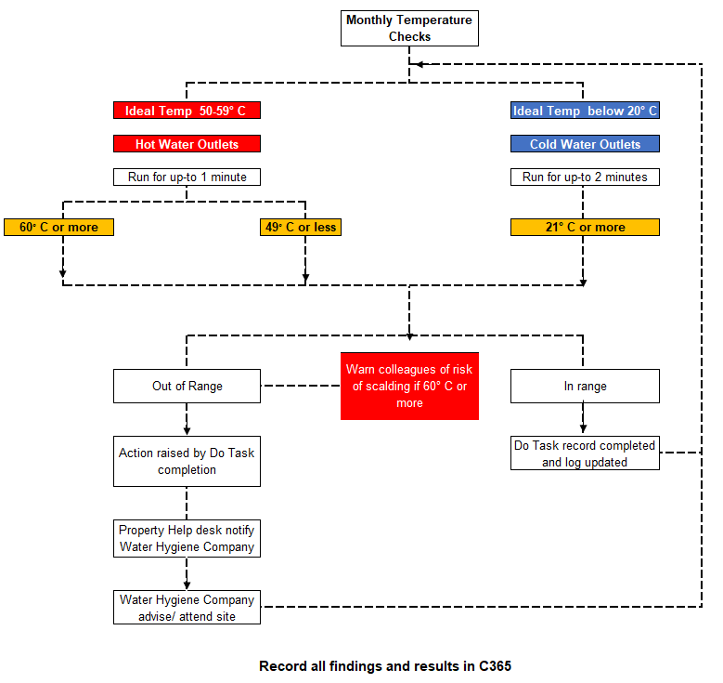
Emergency Actions if not using C365 Do Tasks to complete record keeping

- Sentinel Outlets - Excessive Time to reach temperature
If outlet takes most of the minute to reach temperature record this detail, and review when next completing activity. If this is repeated at next check, contact Property Services Helpdesk

- Hot Water Sentinel Outlets - below 50 degrees
If temperature is below 50 degrees after running for up-to 1 minute report to Property Services for follow up action and advice from Water Hygiene Contractor

- Hot Water Sentinel Outlets - above 60 degrees
If temperature is above 60 degrees, report to Property Services for follow up action and advice from Water Hygiene Contractor.
Warn all Colleagues of risk of scalding.

- Cold Water Sentinel Outlets - above 20 degrees
If temperature is above 20 degrees after 2 minutes on second activity report to Property Services for follow up action and advice from Water Hygiene Contractor.

- Annual Task - Temperature Probe Calibration
All sites will have temperature probes checked against calibrated units during the annual contractor review visit or replaced if not within tolerance (+/- 5%).
If necessary, sites can calibrate a probe by referring to Appendix 6

4. Quarterly Task - Shower and Spray Taps
Handheld shower heads:
- Remove the showerhead from the hose. Be careful not to lose the rubber washer when you do as this stops water from leaking between the head and the hose.
- Put the shower head (and hose if possible) in a bucket or plastic container and cover it with lime scale remover solution, leaving it to soak as per product guidelines.
- Take the shower head and hose out of the solution, rinse it with water and polish with a soft cloth.
- Reattach to the hose and turn on the shower to flush out any remaining limescale.
Fixed shower heads:
- Take a plastic bag that is big enough to fit over your showerhead and half fill it with lime scale remover solution
- Place it over the head until the head is completely submerged in the solution and use some string or an elastic band to tie it in place.
- Leave the shower head to soak as per product guidelines
- Turn on the shower to flush out any deposits left inside the showerhead.
- Repeat the process, if necessary, until all the limescale has gone

Descaling Chemical risk assessment:
Descaling granules are available from ChemEco. Only the Society’s approved de-scaling product should be used to complete the task. The Safety Data Sheet is located on Colleague Connect and ChemEco portal if required
Method of Application: | Fill kettle half full, and boil. Add 1 x 10g scoop of granules and leave for 5 minutes. Rinse thoroughly. Repeat process if scale is not completely removed. Sprinkle on a damp cloth and apply directly to shower areas/screens. Rinse.
PPE | Standard rubber gloves
Recommendations: | Rinse items thoroughly after using this product. Use a foaming trigger head when using in a spray bottle
Emergency Procedures:
Skin: | Avoid contact with skin, if product gets onto skin wash with plenty of soap and water and remove contaminated clothing.
Eyes: | Avoid contact with eyes, if product gets into eyes, rinse with water for 15 minutes and seek medical advice
Inhalation: | Avoid inhaling product, move to fresh air if in discomfort and seek medical advice
Ingestion: | Do not drink, if swallowed drinking water may be beneficial, do not induce vomiting and seek medical advice
Spillage of concentrate state: | Put on rubber gloves, using disposable paper towel wipe up spillage. Rinse area with fresh water using mop and bucket - erect wet floor sign

5. Annual Task - Review of water system management
Each year a thorough review of all water system documentation should be undertaken by the Appointed Responsible Person. This will include:

- The L8 (Fourth edition) risk Assessment.
- Records of all tests, inspections and samples relating to the sites water systems.
- All information relating to the management of water systems including detailed responsibilities for all individuals and their corresponding training records.

The purpose of this review is to identify the efficacy of the current approach and spot any trends that might have wider implications before they become a serious issue. It is foreseeable that the review may identify:

- Colleagues holding positions of responsibility for water system management have changed.
- Contractors providing services may have changed.
- Changes in building use both permanent / temporary and/or seasonal.

- Trends of good and bad control.
- Task specific risk assessments are routinely undertaken.
- Method statements are suitably site and system specific.
- Accidents have occurred when undertaking a specific task etc.
- A specific question set should be drawn up to challenge how effective water system management is on any given site.
- Developments in technology and legislation that may further reduce the risk of legionellosis.
- Change in legislation and guidance
- The review should include all allocated responsibilities in the communication pathway.

If the review is done well it is foreseeable that changes to water system management may be identified.

These may include:

- Review of L8 risk assessment.
- Changes to water system schematics and/or design.
- Cleaning/pasteurisation of water systems.
- Provision of refresher or additional training.
- Rewriting of method statements.
- Modification of the written scheme.

Section 3
Appendix 1 Glossary of Key Terms

Calorifier An apparatus used for the transfer of heat to water in a vessel by indirect means, the source of heat being contained within a pipe or coil immersed in the water.
Cold water service (CWS) Installation of plant, pipes and fitting in which cold water is stored, distributed and subsequently discharged.
Dead end/blind end A length of pipe closed at one end through which no water passes.
Deadleg Pipes leading to a fitting through which water only passes when there is draw-off from the fitting.
Domestic water services Hot and cold water intended for personal hygiene, culinary, drinking water or other domestic purposes
Hot water service (HWS) Installation of plant, pipes and fittings in which water is heated, distributed and subsequently discharged (not including cold water feed tank or cistern).
Legionnaires’ disease A form of pneumonia caused by legionella bacteria
Legionellae The genus legionella belongs to the family legionellaceae which has over 40 species. These are ubiquitous in the environment and found in a wide spectrum of natural and artificial collections of water.
Legionella Type of aerobic bacterium which is found predominantly in warm water environments. (singular of legionellae).
L. pneumophila One of the causative organisms of legionnaires’ disease
Legionellosis Any illness caused by exposure to legionella
Sentinel taps For hot water services – the first and last taps on a recirculating system. For cold water systems (or non-recirculating hot water systems), the nearest and furthest taps from the storage tank. The choice of sentinel taps may also include other taps which are considered to represent a particular risk.
TMV Thermostatic mixing valve - Mixing valve in which the temperature at the outlet is pre-selected and controlled automatically by the valve

Appendix 2 Checklist for hot and cold water systems
Extract from HSG 274 Part 2: The control of legionella bacteria in hot and cold water systems
Service | Action to take | Frequency
Calorifiers | Inspect calorifier internally by removing the inspection hatch or using a boroscope and clean by draining the vessel. The frequency of inspection and cleaning should be subject to the findings and increased or decreased based on conditions recorded | Annually, or as indicated by the rate of fouling
 | Where there is no inspection hatch, purge any debris in the base of the calorifier to a suitable drain Collect the initial flush from the base of hot water heaters to inspect clarity, quantity of debris, and temperature | Annually, but may be increased as indicated by the risk assessment or result of inspection findings
 | Check calorifier flow temperatures (thermostat settings should modulate as close to 60 °C as practicable without going below 60 °C) Check calorifier return temperatures (not below 50 °C, in healthcare premises not below 55 °C) | Monthly
Hot water services | For non-circulating systems: take temperatures at sentinel points (nearest outlet, furthest outlet and long branches to outlets) to confirm they are at a minimum of 50 °C within one minute (55 °C in healthcare premises) | Monthly
 | For circulating systems: take temperatures at return legs of principal loops (sentinel points) to confirm they are at a minimum of 50 °C (55 °C in healthcare premises). Temperature measurements may be taken on the surface of metallic pipework | Monthly
 | For circulating systems: take temperatures at return legs of subordinate loops, temperature measurements can be taken on the surface of pipes, but where this is not practicable, the temperature of water from the last outlet on each loop may be measured and this should be greater than 50 °C within one minute of running (55 °C in healthcare premises). If the temperature rise is slow, it should be confirmed that the outlet is on a long leg and not that the flow and return has failed in that local area | Quarterly (ideally on a rolling monthly rota)
 | All HWS systems: take temperatures at a representative selection of other points (intermediate outlets of single pipe systems and tertiary loops in circulating systems) to confirm they are at a minimum of 50 °C (55 °C in healthcare premises) to create a temperature profile of the whole system over a defined time period | Representative selection of other sentinel outlets considered on a rotational basis to ensure the whole system is reaching satisfactory temperatures for legionella control
POU water heaters (no greater than 15 litres) | Check water temperatures to confirm the heater operates at 50–60 °C (55 °C in healthcare premises) or check the installation has a high turnover | Monthly–six monthly, or as indicated by the risk assessment
Combination water heaters | Inspect the integral cold water header tanks as part of the cold water storage tank inspection regime, clean and disinfect as necessary. If evidence shows that the unit regularly overflows hot water into the integral cold water header tank, instigate a temperature monitoring regime to determine the frequency and take precautionary measures as determined by the findings of this monitoring regime | Annually
 | Check water temperatures at an outlet to confirm the heater operates at 55–60 °C | Monthly
Cold water tanks | Inspect cold water storage tanks and carry out remedial work where necessary | Annually
 | Check the tank water temperature remote from the ball valve and the incoming mains temperature. Record the maximum temperatures of the stored and supply water recorded by fixed maximum/minimum thermometers where fitted | Annually (Summer) or as indicated by the temperature profiling
Cold water services | Check temperatures at sentinel taps (typically those nearest to and furthest from the cold tank, but may also include other key locations on long branches to zones or floor levels). These outlets should be below 20 °C within two minutes of running the cold tap. To identify any local heat gain, which might not be apparent after one minute, observe the thermometer reading during flushing | Monthly
 | Take temperatures at a representative selection of other points to confirm they are below 20 °C to create a temperature profile of the whole system over a defined time period. Peak temperatures or any temperatures that are slow to fall should be an indicator of a localised problem | Representative selection of other sentinel outlets considered on a rotational basis to ensure the whole system is reaching satisfactory temperatures for legionella control
 | Check thermal insulation to ensure it is intact and consider weatherproofing where components are exposed to the outdoor environment | Annually
Showers and spray taps | Dismantle, clean and descale removable parts, heads, inserts and hoses where fitted | Quarterly or as indicated by the rate of fouling or other risk factors, e.g. areas with high risk patients
Base exchange softeners | Service and disinfect | Annually, or according to manufacturer’s guidelines
Multiple use filters | Backwash and regenerate as specified by the manufacturer | According to manufacturer’s guidelines
Infrequently used outlets | Consideration should be given to removing infrequently used showers, taps and any associated equipment that uses water. If removed, any redundant supply pipework should be cut back as far as possible to a common supply (e.g. to the recirculating pipework or the pipework supplying a more frequently used upstream fitting) but preferably by removing the feeding ‘T’ Infrequently used equipment within a water system (i.e. not used for a period equal to or greater than seven days) should be included on the flushing regime Flush the outlets until the temperature at the outlet stabilises and is comparable to supply water and purge to drain Regularly use the outlets to minimise the risk from microbial growth in the peripheral parts of the water system, sustain and log this procedure once started For high risk populations, e.g. healthcare and care homes, more frequent flushing may be required as indicated by the risk assessment | Weekly, or as indicated by the risk assessment
TMVs | Risk assess whether the TMV fitting is required, and if not, remove  Where needed, inspect, clean, descale and disinfect any strainers or filters associated with TMVs  To maintain protection against scald risk, TMVs require regular routine maintenance carried out by competent persons in accordance with the manufacturer’s instructions. There is further information in paragraphs 2.152– 2.168 | Annually or on a frequency defined by the risk assessment, taking account of any manufacturer’s recommendations
Expansion vessels | Where practical, flush through and purge to drain | Monthly–six monthly, as indicated by the risk assessment

Appendix 3 Example of Site Schematic
Example of schematic drawing typically found in the Legionella Risk Assessment
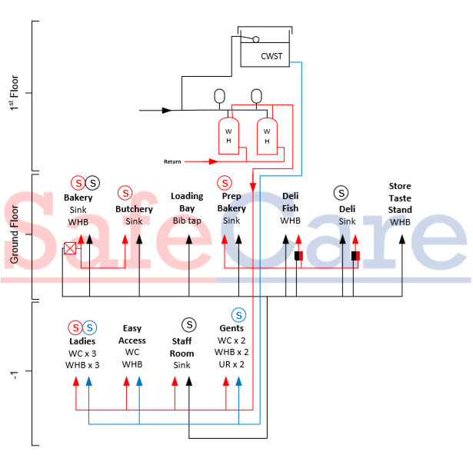

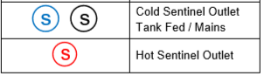
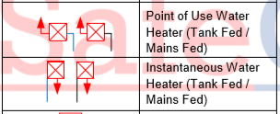

Appendix 4 Sample Levels - Legionella
Legionella bacteria (cfu/l) | Recommended actions
More than 100 but less than 1,000 | Either:  - If the minority of samples are positive, the system should be resampled. If similar results are found again, a review of the control measures and risk assessment should be carried out to identify any remedial actions necessary or  - If the majority of samples are positive, the system may be colonised, albeit at a low level. An immediate review of the control measures and risk assessment should be carried out to identify any other remedial action required. Disinfection of the system should be considered
More than 1,000 | The system should be resampled and an immediate review of the control measures and risk assessment carried out to identify any remedial actions, including possible disinfection of the system. Retesting should take place a few days after disinfection and at frequent intervals afterwards until a satisfactory level of control is achieved.

Appendix 5 References
The following references were employed:
- Health & Safety at Work, etc Act 1974 – (C37) The Stationary Office 1974 ISPN 978 0 10 543774
- Control of Substances Hazardous to Health Regulations - Health & Safety Executive. HSE books 2013. Approved Code of Practice and Guidance L5 (Sixth edition) ISPN 978 0 7176 6582 2 www.hse.gov.uk/pubns/books/l5.htm
- The Management of Health Safety at Work Regulations SI 3242/1999 The Stationary Office
- Legionnaires’ Disease: A guide for duty holders leaflet INDG458 HSE books 2012 www.hse.gov.uk/pubns/indg458.htm
- L8 (Fourth edition) Legionnaires’ disease, the control of legionella bacteria in water systems
- Reporting accidents and incidents at work: A brief guide to the Reporting of Injuries, Diseases and Dangerous Occurrences Regulations 2013 (RIDDOR) Leaflet INDG453(rev 1) HSE Books 2013 www.hse.gov.uk/pubns/indg453.htm

Appendix 6
Calibrate a probe thermometer using an ice bath
If required - Food and Childcare Sites

The easiest way to test the accuracy of any thermometer is in a properly made ice bath. If you do this carefully, your ice bath will be 0°C within ±0.1°C. If you are not careful, the ice bath can be off by several whole degrees. (Just a cup with ice water in it can be 12 or more degrees too high.)

Step One: Fill with ice

Making a proper ice bath is all about keeping a proper ice-to-water ratio. Fill a vessel all the way to the top with ice. Crushed ice is preferred because there are fewer gaps between the ice, however cubed ice will also work fine.

Step Two: Add Water

Slowly add water to fill the spaces between the ice. Fill about 1/2" below the top of the ice. Let the mixture sit for a minute or two to allow the temperature of the water to settle. If you see the ice starting to float off the bottom of the vessel, pour off some water and add more ice. Water below the ice will not be at 0°C.

Step Three: Insert the Probe

Once the mixture has rested for a minute or two, insert your probe (or thermometer stem) into the mixture and stir in the vertical centre of the ice slurry. Stirring the probe keeps the sensor from resting against an ice cube, which will affect your reading. Keep the probe tip away from the side walls and don't allow it to rest against the bottom of the vessel. Doing so will give you inaccurate temperature readings. You MUST gently stir the probe, or you will find colder and warmer spots in the ice bath. Stirring equilibrates the temperature throughout the vessel.

Step Four: Confirm Calibration

Your thermometer should read 0°C in the ice bath. Adjust your dial thermometer as directed by the manufacturer; however, before you attempt to adjust a digital, instant-read thermometer, check that the readings are within the manufacturer’s accuracy specifications. (Look for a ±°C on the documentation included with the instrument.) If it's within the specified tolerance, don't adjust.

Non-Food Sites

Managers of stand-alone, non-food sites who cannot carry out this calibration procedure, must ensure the probe thermometer is checked against the Water Hygiene Contractor’s calibrated unit and replace where out of tolerance (+/- 5%)
Policy name: | Calibrate probe thermometer | Date of Last Review: | 22/1/2021

