Following an accident or incident on site, locate the required accident form in your site’s pool.
- For colleague and customer accidents please select the Accident and Incident reporting form 2026.
- For child accidents please select child accident reporting 2026.
“Take” and “Start” the right task as normal entering all the details in the various steps
- Once the form is fully filled in, you will be asked to “Submit Task”
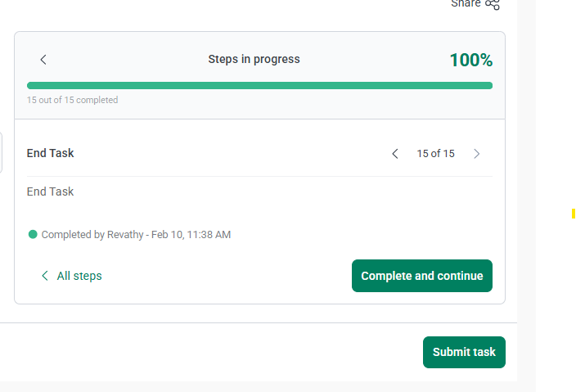
- H&S Team will then be able to review the accident form and will approve the task as “completed”, if the form covers all the required information.
- If any information is missing on the form, or more detail is required, the particular step will be “Rejected” and the form will come back to the site location to “Redo”. A “reviewer’s note” will be added to the rejected step explaining why the step is rejected and what additional action is required.
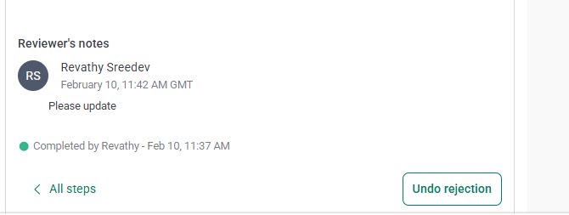

- The “rejected” accident form will appear with the status “Redo” under “My Tasks”

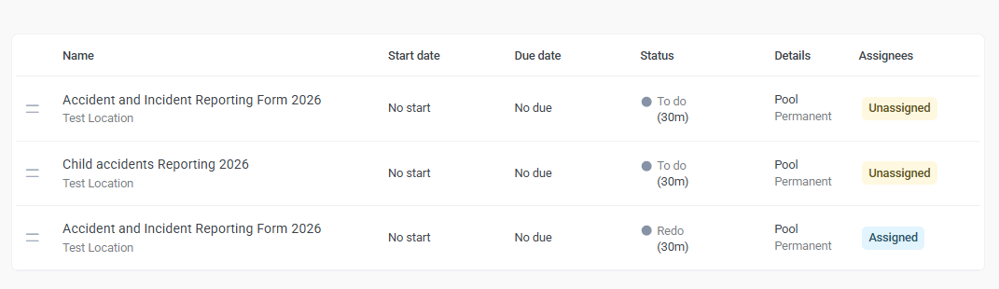

- Select, take and start the task as normal.

- Navigate to any step that is showing as “Rejected”, and update the rejected steps using the information included by the H&S Team. Once the step is updated, “Save and continue”.

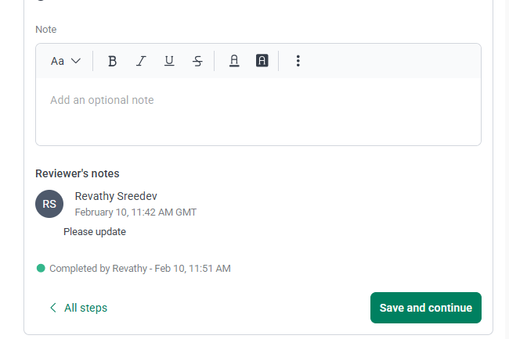

- Repeat this for all rejected steps and then “Submit task” again for review.

