Meeting Title: Health and Safety Meeting
Meeting Date: 23/3/23 | Meeting Time | 15.30
Meeting Location: Virtual | Teams
Chair | Edward Parker | EP
Secretary and note taker | Mick Tattersall | MT

Present
Emma Brown - EB | JM- James Marriott - Guest
Meg Stone - MS | Andy Fawlk - AF
Mandy Parker - MP | Mick Tattersall - MT
John Woodward -JW | Edward Parker - EP
Alison Holmes - HW | Darren Adams - DA
Chris Mason - CM | Carla Moore - CM

Apologies:
Suzi Willis/ Kathryn Lyddon/ Anna O'Leary/Nicole Jones/ Clare Ball

Meeting Starts: 15.33

Introduction and welcome
EP- Outlines shorter format of the meeting due as a Kick Off
More collaborative approach
EP- Terms of Reference outlined - re the changes from previous year's version/ comms and awareness/ superior pay attention/ ensure exec engagement/ share best practice
Need to identify a Union member
Anna to join as secretary
2 way comms important/ need to understand what the business is telling us/ what works/ doesn’t work
Need you to take material back to your Groups for consideration
Next meeting will include ROSPA to discuss best practice sharing
Questions? None

Highlights from Pre-meeting shared material
MT runs through highlights of summary
EP - Wins with losing the c365 actions/ thanks from the Exec on last Year's efforts
Reminder to read everything sent. The Board pack needs to be read to better understand/ useful as a reference .
We as committee have a responsibility to be aware and share through the business. Our responsibility but need to drive it.

Upcoming H&S events
MT - runs through the deck.
Reminder of Board commitment for H&S
Proposal for self-auditing for low risk stores/ stores not receiving a visit
Work Jam summary
JW - Could we seek feedback from sites on workjam use - better than before
CM - Think about the same but some changes to be made
Dashboards?
AF- Video which really worked well. Support desk is working well and trying to understand. Checking what has been completed. Paper version being done as a back-up
MP - Update - tasks not needed - Suggest chasing support

Group Feedback
DA - Till screens - retail. H&S View?
Andy did a great video that was shared for WJ
EP - Screens in Travel?
MP - No, started to come down. Causing some damage so raised with helpdesk. Colleague sin the main are happy but can keep if want to. A few sites have chosen to keep them.
EP - MT to prep a briefing paper on screens
AF - Fire evacuations in the event of a non-fire?
ACTION - PA comments on process to follow share with the Groups -MT

Colleague Engagement/ 1 pager
MT - Outlines the incident and asks for thoughts on colleague engagement.
EP - How can we get people to do things right/ fix first time/ a think about promoting the right behaviours
Think the right way/ making the right fuss to get things done?
ROSPA - Reminder next meeting face to face and will; include a session on this
AF- Educational - recently completed
Better at fixing things straight away/ get people aware of consequences
EP - Exec could do with a boost there. Perhaps create a vision / strap line to enforce message
CM - Cultural - encourage to keep raising tickets if not getting fixed/ fixed properly
DA - Yes, it is educational/ any visitor's responsibility to raise issues with a store -all duty of care. Property - is there a build on this- mechanism to improve the fix. Doesn’t remedy the risk.
ACTION - MT to set up committee attendees with the module
ACTION - MT - KL re repairs following accident

Date/next meeting: TBC but will be in person Late April. All to attend a there will be a workshop with ROSPA to discuss engagement.

Risk Register/ H&S
JM - Risk appetite and management. A risk register for the Society.
High on the Register , at #5
Phil currently the owner. Open question, is Phil the right person for the risk? For consideration
Behind the register is a sub register and this allows the Board sets our risk appetite
Real focus is the residual risk - currently risk tolerance is exceeded tolerance
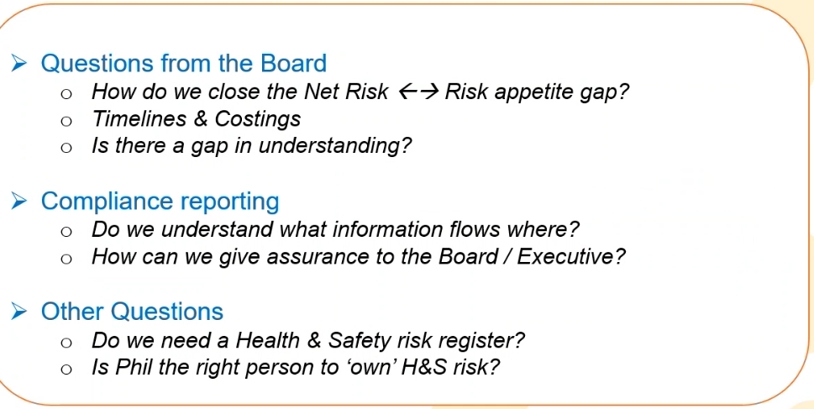

EP - Committee members take away the questions for consideration at future meetings
EP - Closes meeting

Meeting Closes @ 16.40 pm

