1) Accident Statistics

Accident overview

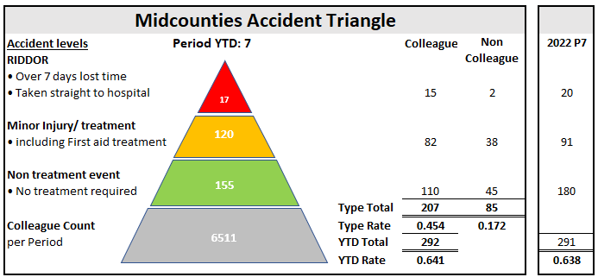

Colleague Accident trends

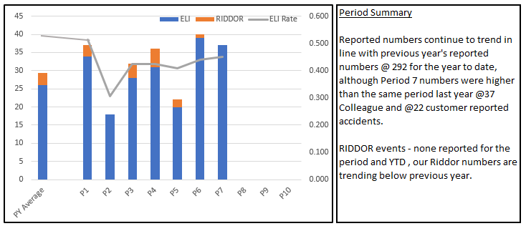

Benchmarking:
We continue to benchmark our accident statistics against other Societies (the last activity was Q2’23). Of note our accident statistics are comparable with Central England co-operative who have similar colleague numbers and sites to Midcounties. Periodic rises and fall appear to be consistent across the Societies.

Reporting is consistent across the 3 key accident types currently included in the activity – Slips/trips and falls; Manual Handling and Struck by - although of note, overall accident type contribution is similar for all Societies.

¹Note: Childcare accidents not included in Benchmarking as unique to Midcounties
²Note: COOP Group and Central England did not submit data for this period which has impacted the results – typically higher number of events and RIDDORs
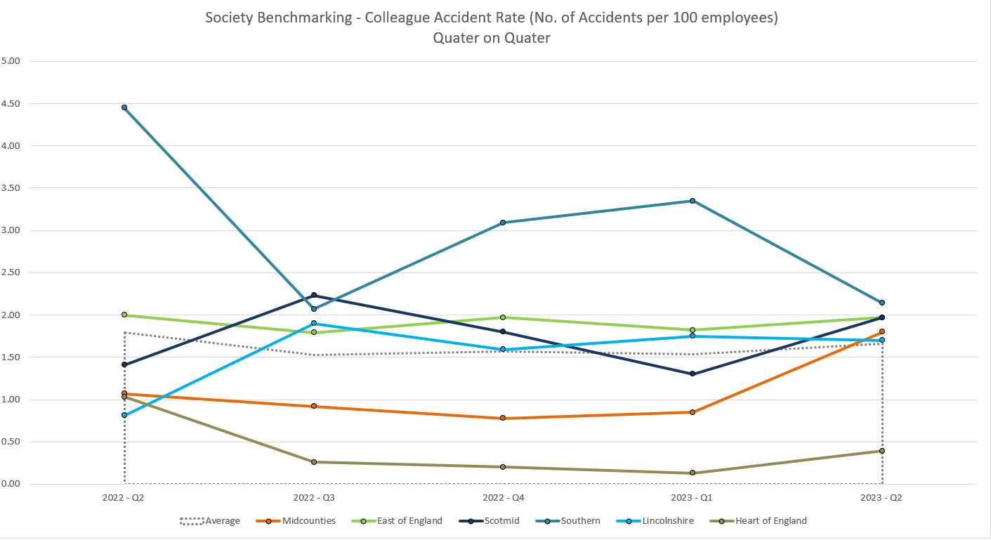

Accident types:
Top 2 Colleague accident types
- Object related (struck by/caught by/entrapped by/ struck) – 31% of accidents
- Slips trips and falls – 17% of accidents
Top 2 Customer accident types
- Slips trips and falls - 58% of accidents
- Object related (struck by/caught by/entrapped by/ struck) - 30% of accidents

RIDDOR Details:
A reminder that all incidents must be reported in a timely manner as there is a legal duty to report within 15 days under RIDDOR guidance. Failure to report correctly can result in significant fines.

Colleague RIDDOR= 11 to date; 10 result of lost time ( over 7 days absence), 1 specific injury
Customer RIDDOR = 1 to date; Taken directly to hospital

Unable to identify days lost currently through WorkJam reporting

Benchmarking
Our typical RIDDOR run rate has worsened compared to other Societies and has been influenced by 2 events relating to shoplifters/ abuse
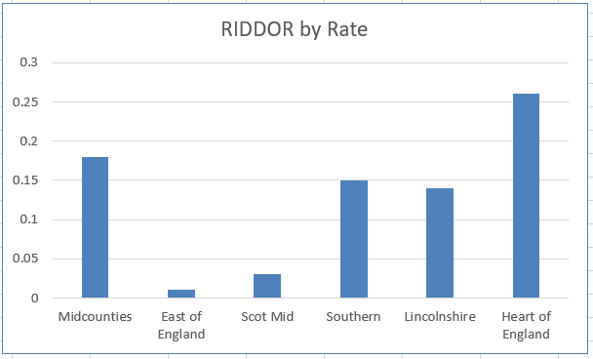

Colleague accidents resulting in lost time (7 days or more) account for over 90% of RIDDOR events YTD
Customers going directly to hospital account for 100% of RIDDOR events YTD

Steering Wheel Measures:
Overall numbers continue to trend positively. Of note, targets set for 2023 (500) have been aligned with actual Society accident statistics and trends and so should prove to be more challenging.

2) Site Compliance Summary

“Site Compliances” - site based H&S compliance activities

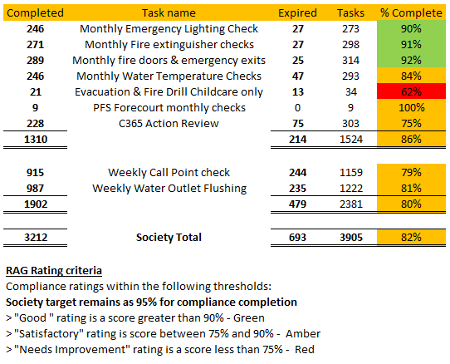

The Society performance has remained consistently in the low to mid 80% since migrating to WorkJam in February and has never met the Society target of 95% .improved throughout the 2nd half of 2022 although never consistently reaching the 95% target.

Performance statistics will continue to be shared with the Executive and Executive Risk Committee for further support.

H&S Site Activities
A disappointing completion rate for the annual H&S Calendar events that were pre-agreed with each Group and scheduled accordingly, although a number were released at the same time as WorkJam was rolled out. One for increased focus when rolling out next year’s activities

Activities were re-set for those sites which missed the deadline and are now fully completed.

Original version release completion
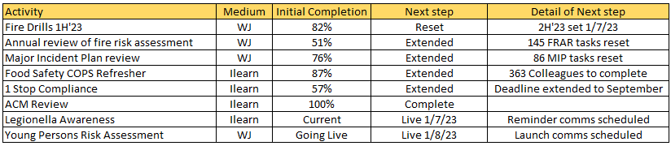

Of note, 2nd half Fire Drills for non-Childcare sites sits at 44% to date and requires a reminder to complete ahead of peak trading periods in Food/PO.

3) Site Action status Summary

The audit program action review practice is greatly improved (compared with previous C365 activity) since migrating to WorkJam with current WorkJam action completion at 93% ( Of @700 actions, 650 have been completed and a further 53 actions are in progress)

There remain @600 actions relating to the Property Compliance programs assigned to site management in C365. Of these, @500 are overdue despite the WorkJam C365 Action review task being implemented in July.

Risk status of overdue actions currently showing in C365
- 32% (Previously 31%) High risk
- 21% (Previously 26%) Medium risk
- 47% (Previously 43%) Low Risk

4) Audit Program

The Audit program continues through 2023 with primary focus on High Risk sites and those sites without a recent audit following the suspension of the program during 2020-21. There was a delay in the program commencing due to WorkJam and so we are currently slightly behind planned completion numbers.

Health & Safety Audit
We completed 97 H&S Audits, focusing on the high risk sites, with an average Society score of 92%
(ranging from 78% - 100% ) and generated approx. 500 actions and recommendations. Scoring remains in line with last year’s numbers .

Completed H&S Audits
- 83 Food and Post Office – average 93%
- 14 Childcare – average 90%
- 0 Travel – TBC

Despite the late start with WorkJam, the plan is to complete the year’s target @180 audits for the year.

Food Safety Audit
We completed 82 Food Safety audits to date, with an average scoring of 89% (ranging from 68% to 99%) and generated approx. 200 actions and recommendations. Scoring remains consistent with previous year.

Despite the late start with WorkJam, the plan is to complete a further @100 food safety sites by year end

Completed Food Safety audits by Group
- 71 Food – average 88%
- 11 Childcare – average 90%

Common Audit Failings

Top 5 failings (25% of all findings):
- Food safety: Thermometer calibration
- Food Safety: Allergen Information
- Food Safety: Roles and Responsibilities for food safety -annual review
- H&S: Access to electrical panels
- H&S: COPS training completion
- H&S: Fire Warden Training

H&S Audit Plan

We identified a capacity to complete @180 H&S audits in a year with a plan to place additional focus on High Risk sites. Typically, we will visit:
- 100% of High Risk sites plus second visits to a further 25% of the High Risk estate
- 10% of Low Risk sites
- Balance of audit count will be Medium Risk sites typically @30%
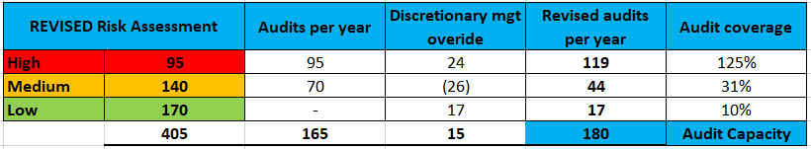

Note: New sites will be classified as High Risk until visited.

5) EHO/” Scores on the Doors Food Hygiene Ratings”

Overall, the Society has 87% of sites on a 5* or 4* rating, following 53 EHO visits in 2023, with a further 26 sites awaiting a visit. 89% of the Childcare estate has received a visit in 2023 (45 sites)

Stonehouse Food Store remains on a 1* rating and Rathvilly Nursery and Middleton Cheney remain on a 2* rating.

All 3 sites have improvement plans in place but were heavily marked down due to poor levels of hygiene and cleaning.

Society ratings summary, 2023 YTD

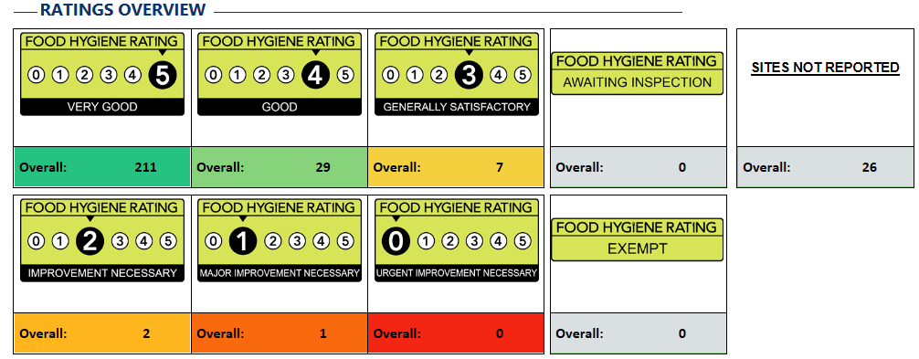

6) H&S Training Summary

i.Learn completion

Less than 88% of planned i.Learn training has been completed by the end of P7 despite regular reminders and escalations.

Appointed Persons and Emergency First Aid at Work
Appointed person training is still available via iLearn for those sites with less than 25 colleagues.

Emergency first aid at work face to face sessions remains an issue and despite booking extra sessions, site take up to attend is a challenge. Operationally Food Group needs to find a solution to site teams attending these important sessions as they are expensive, and non-attendance isn’t an option ( (Maximum attendance is 12 hours).

One for discussion at the Committee Meeting - next session 3/10/23 at Bicton Heath (only 5 booked on); 11/10/23 at Queensway (only 3 booked on); 11/10/2023 at Cainscross ( fully booked); 19/10/23 at Phone COOP (Only 6 booked on)

Fire Warden/Marshal training
There is now a PowerPoint version available on iLearn for any SM/ Site team requiring training. Not an ideal training delivery and we will look at options for 2024.

Asbestos Awareness training
Unfortunately, @75 Site Managers failed to take advantage of the Liberty Mutual training module.

We are looking to secure suitable training material for next year’s planned awareness training and looks likely to be High Speed learning. I will provide an update shortly.

