1) Accident Statistics P11 YTD

Accident overview

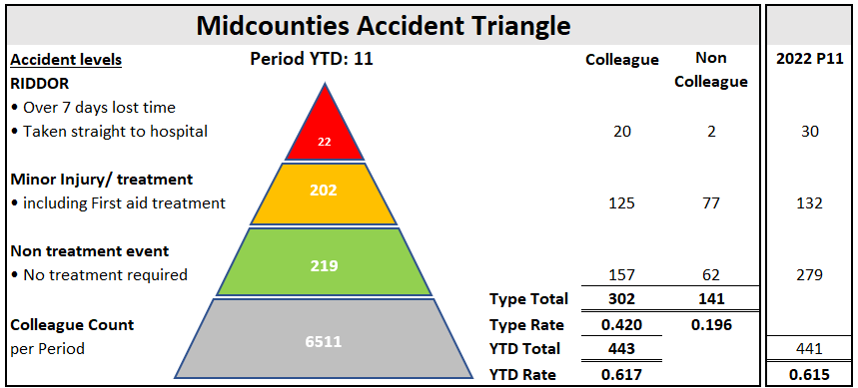

Colleague Accident trends

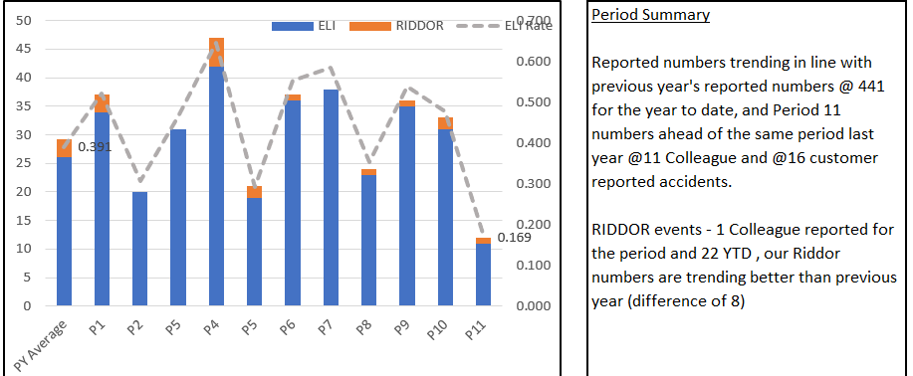

Benchmarking:
We continue to benchmark our accident statistics against other Societies (the last activity was Q3’23). Of note our accident statistics are comparable with Central England co-operative who have similar colleague numbers and sites to Midcounties. Periodic rises and fall appear to be consistent across the Societies.

Reporting is consistent across the 3 key accident types currently included in the activity – Slips/trips and falls; Manual Handling and Struck by - although of note, overall accident type contribution is similar for all Societies.

¹Note: Childcare accidents not included in Benchmarking as unique to Midcounties
²Note: COOP Group and Central England did not submit data for this period which has impacted the results – typically higher number of events and RIDDORs
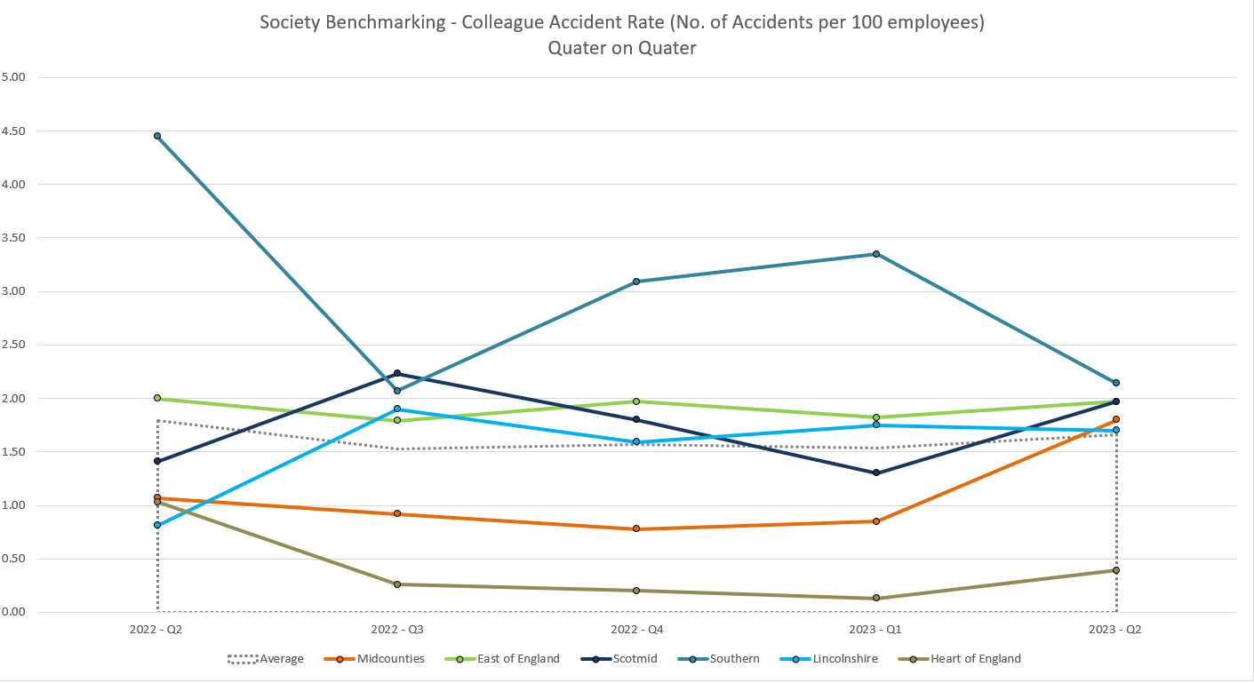

Accident types:
Top 2 Colleague accident types
- Object related (struck by/caught by/entrapped by/ struck) – 31% of accidents
- Slips trips and falls – 17% of accidents
Top 2 Customer accident types
- Slips trips and falls - 58% of accidents
- Object related (struck by/caught by/entrapped by/ struck) - 30% of accidents

RIDDOR Details:
A reminder that all incidents must be reported in a timely manner as there is a legal duty to report within 15 days under RIDDOR guidance. Failure to report correctly can result in significant fines.

Colleague RIDDOR= 20 to date; 19 result of lost time (over 7 days absence), 1 specific injury
Customer RIDDOR = 2 to date; Taken directly to hospital

Unable to identify days lost currently through WorkJam reporting

Benchmarking
Our typical RIDDOR run rate has worsened compared to other Societies and has been influenced by 2 events relating to shoplifters/ abuse
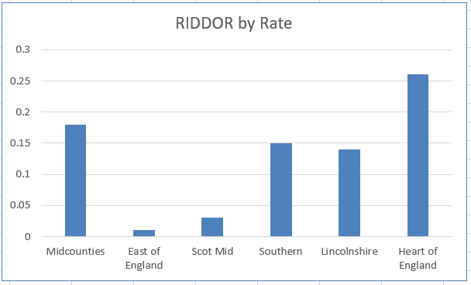

Colleague accidents resulting in lost time (7 days or more) account for 95% of RIDDOR events YTD
Customers going directly to hospital account for 100% of RIDDOR events YTD

Steering Wheel Measures:
Overall numbers continue to trend positively. Of note, targets set for 2023 (500) have been aligned with actual Society accident statistics and trends and so should prove to be more challenging.
Target set for 2024 at 375.

2) Site Compliance Summary P11

“Site Compliances” - site based H&S compliance activities

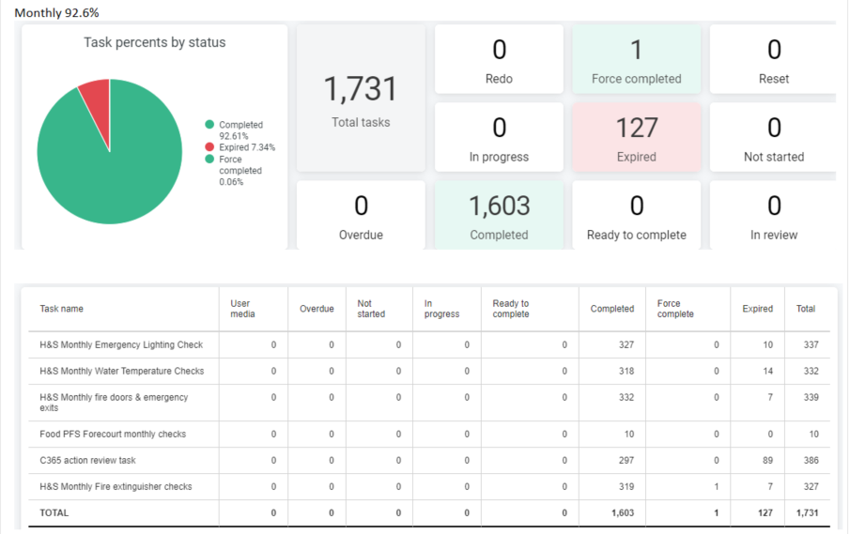

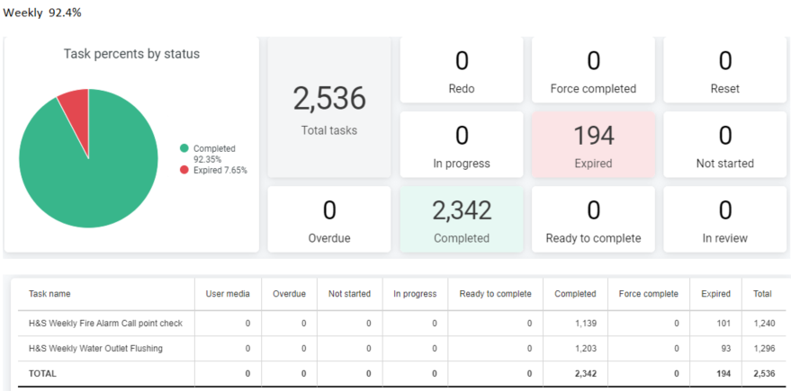

The Society performance in this area has steadily improved throughout 2023 and is now consistently meeting and often exceeding the performance seen in C365 during 2022.

Society target remains at 95% and at Society level we are still marginally adrift, although there is an opportunity to move the needle further by completing a cleanse of workjam tasks for certain sites that do not need to complete the tasks. Offices and Travel remain the key areas for improvement.

Performance statistics will continue to be shared with the Executive and Executive Risk Committee for further support.

H&S Site Activities
A disappointing completion rate for the annual H&S Calendar events that were pre-agreed with each Group and scheduled accordingly, although a number were released at the same time as WorkJam was rolled out. Considering the improving completion rates in workjam in the last few months, it is expected that completion of the 2024 calendar of events will be better implemented

See below 2023 performance by task
Original version release completion
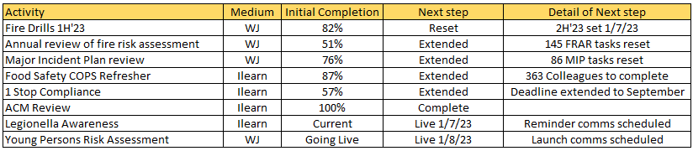

3) Site Action status Summary

The audit program action review practice is greatly improved (compared with previous C365 activity) since migrating to WorkJam with current WorkJam action completion at 93% ( Of @700 actions, 650 have been completed and a further 53 actions are in progress)

There remain 349 actions relating to the Property Compliance programs assigned to site management in C365 (down from @600 in July 2023). The bulk of these are overdue despite the Monthly WorkJam “C365 Action review” task being implemented in July, but a reflection of the December completion performance of the task at only 74% .

Risk status of overdue actions currently showing in C365
- 11% (Previously 31%) High risk
- 27% (Previously 26%) Medium risk
- 62% (Previously 43%) Low Risk

4) Audit Program

The Audit program continues through 2023 with primary focus on High Risk sites and those sites without a recent audit. There was a delay in the program commencing due to WorkJam and so we are currently slightly behind planned completion numbers.

Health & Safety Audit
We completed 134 H&S Audits, focusing on the high risk sites, with an average Society score of 92%
(ranging from 78% - 100% ) and generated approx. 1000 actions and recommendations, of which sites have closed out 92%, a further 13% are overdue. Overall audit Scoring remains in line with last year’s numbers .

Completed H&S Audits
- 110 Food and Post Office – average 93%
- 22 Childcare – average 86%
- 2 Travel – average 92%

Workplace Transport Risk Assessments (WTRA) – Food Stores
Following a number of EHO visits late in 2023, we have had to pull the planned 2024 WTRA program forward as an appeasement for negative findings on site. This has had a further impact on audit completion numbers, and to date have completed @45 Audits.

Food Safety Audit
Despite the late start with WorkJam, we completed 121 Food Safety audits to date, with an average scoring of 89% (ranging from 68% to 99%) and generated approx. 885 actions and recommendations, of which sites have closed out 78%, a further 7% are overdue.

Scoring remains consistent with previous year.

Completed Food Safety audits by Group
- 108 Food – average 88%
- 13 Childcare – average 90%

Common Audit Failings

Top failings per Audit (40% of all findings):
Food safety Audit:
- General condition of building and storage areas
- Thermometer calibration
- Allergen Information
- Roles and Responsibilities for food safety -annual review
H&S Audit:
- Workjam H&S Task completion
- Access to electrical panels
- Various training not completed
- Risk assessment reviews not completed

H&S Audit Plan

We identified a capacity to complete @180 H&S audits in a year with a plan to place additional focus on High Risk sites. Typically, we will visit:
- 100% of High Risk sites plus second visits to a further 25% of the High Risk estate
- 10% of Low Risk sites
- Balance of audit count will be Medium Risk sites typically @30%
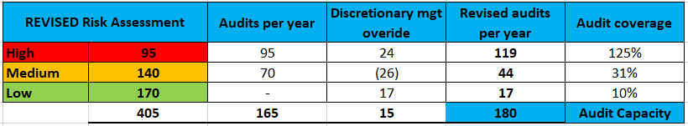

Note: New sites will be classified as High Risk until visited.

5) EHO/” Scores on the Doors Food Hygiene Ratings”

Overall, the Society has 86% of sites (235) on a 5* or 4* rating (slightly down from P8 reporting 87% /240 sites) , following 70 EHO visits in 2023, with a further 27 sites awaiting a visit.

Stonehouse Food Store remains on a 1* rating and Rathvilly Nursery and Middleton Cheney remain on a 2* rating.

All 3 sites have improvement plans in place but were heavily marked down due to poor levels of hygiene and cleaning.

Society ratings summary, P11 2023 YTD

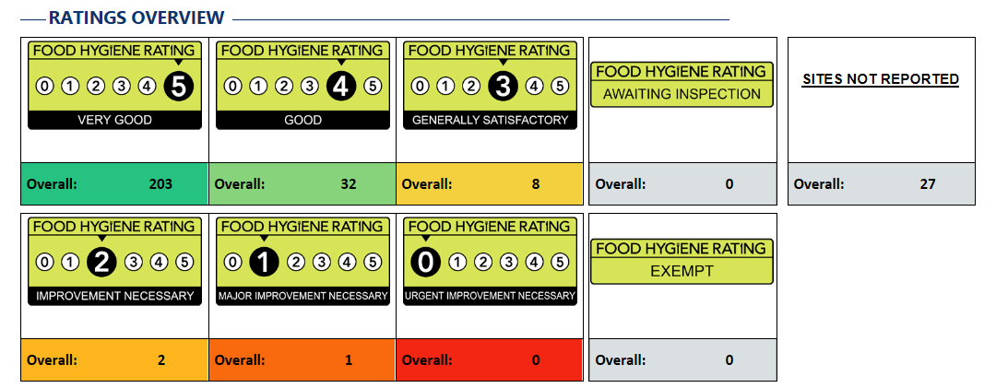

Pest control
An emerging issue across the Society for a number of reasons, including population increases; reduced council baiting and trapping programs; and wet weather.

Summary (provided by Indepth)
During the month of December, we have seen increased focus on the pest control services across the Midcounties estate, alongside increase in communication and reporting. It has been challenging for all parties and we are committed to ensuring that we are meeting the expectations Midcounties coop and also continue to push Pestokill on improving the service provision, reaction times and reporting.

During the month of December there was 308 Visits completed, of these visits 192 was routine, 44 callouts, 72 Follow up visits

Overall site activity stands a 7% overall sites with activity, with NTP/Retail at 6% and Childcare at 14%

Activity on the visits recorded, 22 External Rats, 15 Internal Rats and 11 Internal Mice

Statistics
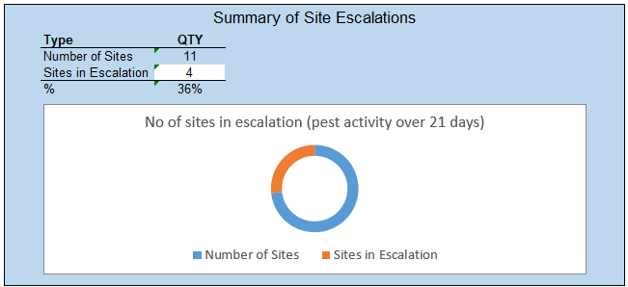

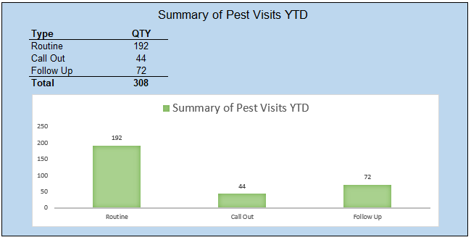

6) H&S Training Summary

i.Learn completion

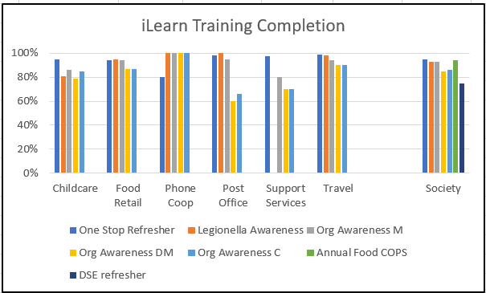

Less than 88% of planned i.Learn training has been completed by the end of P11 despite regular reminders, escalations and deadline extensions. One for discussion at the Meeting.

New starters/ onboarding

New colleague training only at 80% complete, further focus required by Line Managers to ensure that all new colleagues complete their vital and mandatory training within the required time frames.

