Staying Safe Together (SST)
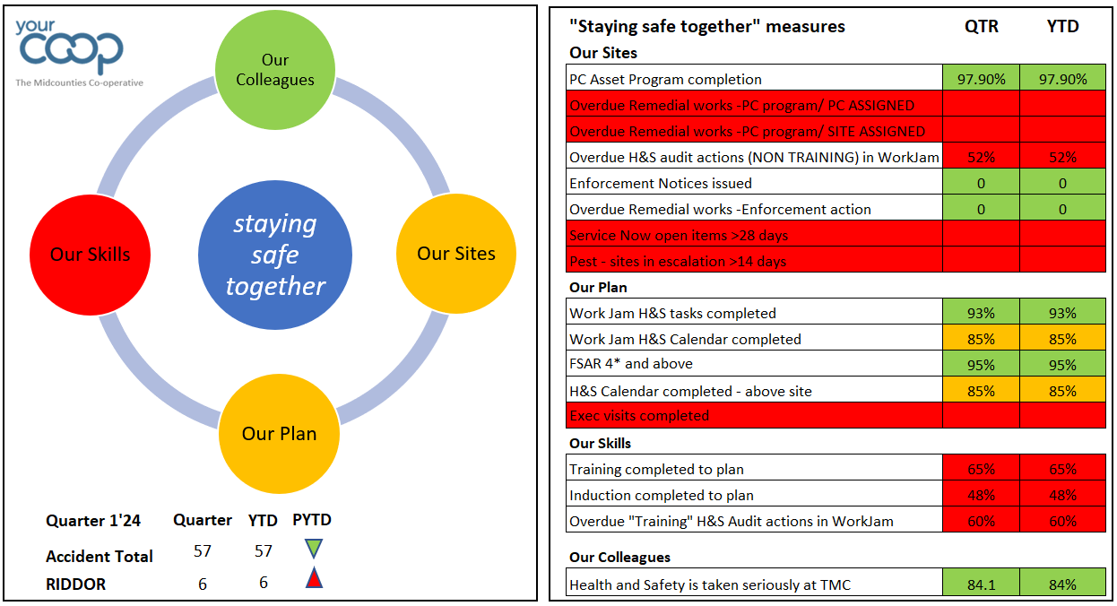

Colleague Accident trends
P2 YTD Summary:
Reported accident numbers are down on previous year (P2YTD’24 57; P2 YTD’23 69),

Colleague accidents remain consistent with previous year (42 P2’24, P2’23 45) which suggests that workjam is now an established platform for the accident reporting task and upgrades and changes made to the form have improved the overall experience and usability.

Accident types:
Top 2 Colleague accident types
- Object related (struck by/caught by/entrapped by/ struck) – 31% of accidents
- Slips trips and falls – 17% of accidents
Top 2 Customer accident types
- Slips trips and falls - 58% of accidents
- Object related (struck by/caught by/entrapped by/ struck) - 30% of accidents

The main reduction in overall numbers has come from customer accident statistics.

A concerning trend is the increased number of RIDDOR reports made during the period, (5 Colleague, 1 Customer) compared with 3 reported in the same period of 2023. This is also an increase on the 5 reported in 2022.

Details are included in the attached RIDDOR report but there are no definitive trends or specific reasons for the events that can be drawn. These would be considered to be casued by behaviour rather than process.
- Colleague RIDDOR= 5 to date; 4 result of lost time (over 7 days absence), 1 specific injury
- Customer RIDDOR =1 to date; Taken directly to hospital

A reminder that all incidents must be reported in a timely manner as there is a legal duty to report within 15 days under RIDDOR guidance. Failure to report correctly can result in significant fines.

Changes made during 2023:
We introduced a formal accident report review process in 2023 and this is now working well , leveraging a functionality within WorkJam. This allows us to improve data entry and critical accident details before the task is approved and will allow us to better defend future Insurance claims and interogate data and trends to reduce accident numbers and severity.

Accident Benchmarking:

We continue to benchmark our accident statistics against other Societies (the last activity was Q4’24). Of note our accident statistics are normally comparable with Central England co-operative who have similar colleague numbers and sites to Midcounties, but they did not submit numbers for the last 2 reporting period. Periodic rises and fall appear to be consistent across the Societies and we trend below the average.

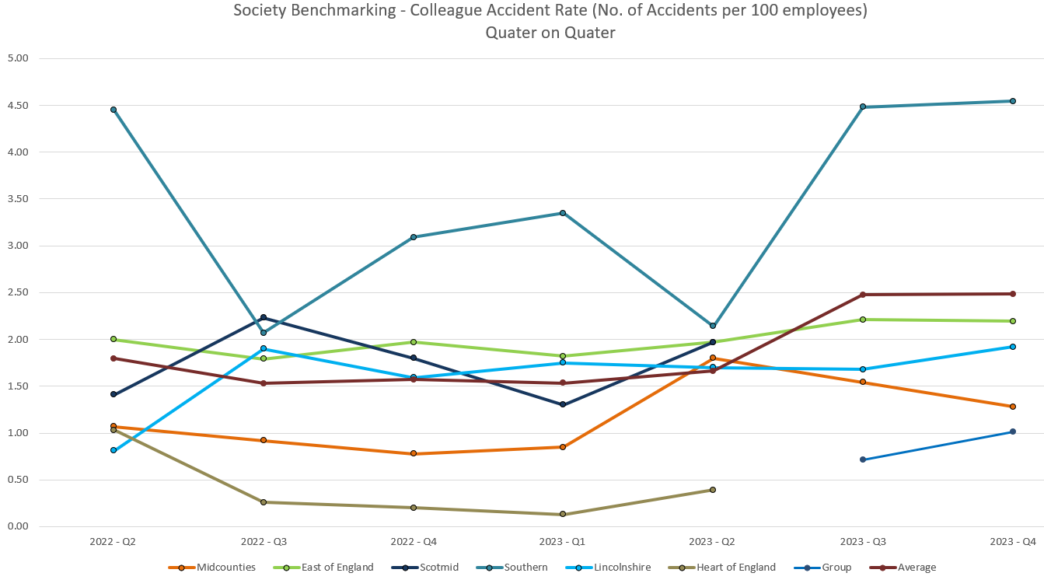

Accident detail is consistent across the 3 key accident types currently included in the activity – Slips/trips and falls; Manual Handling and Struck by - although of note, overall accident type contribution is similar for all Societies.
(¹Note: Childcare accidents not included in Benchmarking as unique to Midcounties_

Benchmarking
Our typical RIDDOR run rate remains comparable to other Societies, with “0ver 7 day” injuries driving reporting and “struck/struck by” casual factors behind the events.

Steering Wheel Measures:
Overall numbers continue to trend positively.

Of note, target set for 2024 (340) has been aligned with actual Society accident statistics and trends and so should prove to be more challenging.

Staying Safe Together – “Our Colleagues”

Initial pulse survey response scored 84.1%, in response to the question “ How serious do you feel TMC is about Health and Safety?”. This in line with the overall Pulse Survey scoring.

Some 290 sites were included in the responses, with 50 scoring below 70%. A plan is being developed

Staying Safe Together – “Our Sites”

Site Compliance Summary P2

“Site Compliances” site based Fire and Water based H&S compliance activities completed in WorkJam

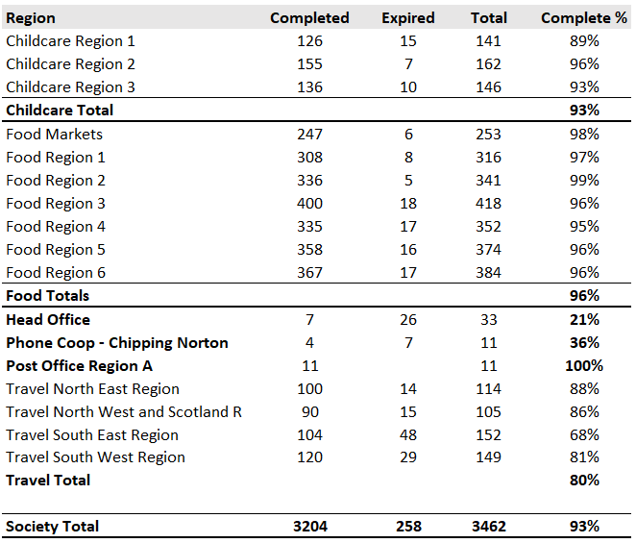

The Society performance in this area has steadily improved throughout 2023 and is now consistently meeting target for most of the Society.

Society target remains at 95% and at Society level we are still marginally adrift, primarily due to expired weekly testing of fire alarms and water flushing tasks. Offices and Travel remain the key areas for improvement.

Completion of the Childcare “Monthly evacuation and drill” task in Workjam has been a challenge through 2023. Despite a poor performance in P1 (65%) , Childcare achieved target in P2. P3 to date is only 33% completion

Performance statistics will continue to be shared with the Executive and Executive Risk Committee for further support.

Site Action status Summary
Action closure from the Fire Risk Assessment, fire equipment and Legionella testing programs (managed in C365) remains below target despite the Monthly Workjam task. March performance, 76% (with 90 sites failing to complete the task).

Although the audit program action review practice is greatly improved (compared with previous C365 activity) since migrating to WorkJam, there are a high number of overdue actions that sites need to review and action. The audit program has generated @800 actions and recommendations.

Nearly 20% of “Non training” related actions are now showing as overdue and should be reviewed in Workjam with a view to closing out.

Pest control
An emerging issue across the Society for a number of reasons, including population increases; reduced council baiting and trapping programs; and wet weather.

Ben Sampson has offered to provide an update at the Committee Meeting

Property related measures
Open and outstanding actions relating to the Property/FM team is an important measure to ensure the safety of our sites, colleagues and visitors and currently there are changes in how these are being managed so we are unable to accurately reflect the status of such actions and raised tickets in service now.

The recent report information provided by the team shows a total of 345 open remedial actions from the various asset testing programs ( of which the Fire Risk Assessment program accounts for 70% (243 remedials ) and Legionella programs account for a further 13% (46 remedials)

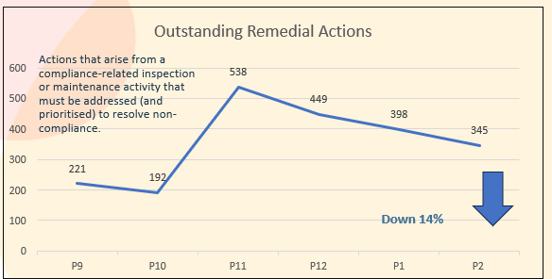

Ben Sampson has kindly offered to provide an update on the plans for the FM/Helpdesk function in 2024 at the Committee Meeting and I ask that you consider what measures would be beneficial for your own Group operations

Exec Site visits
The Executive Team agreed and committed to complete a number of H&S focused site visits this year with the first round starting later his month.

A series of focus topics and questions has been developed to support these visits with an initial plan based around the “tell me/ show me” approach. Fire safety will be the initial focus.

We should be able to feedback on these visits at the next Committee Meeting but have included this as an agenda item to discuss at this Month’s session

Staying Safe Together - “Our Plan”

H&S Site Activities
A disappointing completion rate for the annual H&S Calendar events that were pre-agreed with each Group and scheduled accordingly with only 3 weeks of the Quarter to complete.

- Asbestos Review, only 75% completion. Expired sites have been reassigned the task
- Major Incident Plan review, 71% completion Quarter to date
- Fire Drills, 55% completion Quarter to date

There is an opportunity for sites to be chased and completion rates improved and should be an action for all Groups.

Attached is a copy of the H&S Calendar for 2024

Audit Program

We identified a capacity to complete @180 H&S audits in a year with a plan to place additional focus on High Risk sites. Typically, we will visit:
- 100% of High Risk sites plus second visits to a further 25% of the High Risk estate
- 10% of Low Risk sites
- Balance of audit count will be Medium Risk sites typically @30%
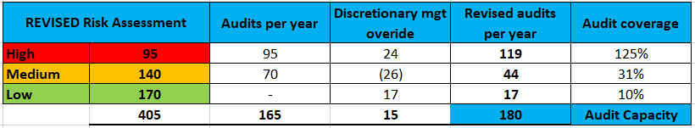

Note: New sites will be classified as High Risk until visited.

A review of the Society’s site risk ratings, for both H&S and Food Safety, was completed in P1 and applied to the audit plan. The calculation assigned 30% of sites as High Risk; 48% as Medium Risk and the balance as Low Risk. This is a marginal reduction in Risk compared to the 2023 calculation, partly due to the completion of sites that had not been audited previously.

WorkJam Audit program
The Audit program commenced 1/4/24 with primary focus on High Risk sites and those sites without a recent audit. There was a small delay in the program commencing due to WorkJam connectivity issues, but this has now been resolved and the program has now recommenced.

Health & Safety and Food Safety Audits
We completed 24 H&S Audits, and 3 Food Safety audits focusing on the high risk sites, with an average Society score of 92% (ranging from 78% - 100% ) and generated approx. 800 actions and recommendations, of which sites have closed out 92%, a further 13% are overdue. Overall audit Scoring remains in line with last year’s numbers .

Common Audit Failings
Top failings per Audit (40% of all findings relate to 9 questions):
- 31 % of findings relate to Fire Safety including:
  - Fire risk assessment review (WorkJam task)
  - Fire Marshal training (an iLearn module)
  - Issues with fire exits and exit routes
  - Overdue Fire Drills
  - Missing fire safety training records
  - Missing fire alarm zone plans

Workplace Transport Risk Assessments (WTRA) – Food Stores
Following a number of EHO visits late in 2023, we had to pull the planned 2024 WTRA program forward as an appeasement for negative findings on site. This program continues in parallel with the H&S and Food Safety audit programs through the first half of this year.

Difficulties in managing the actions and recommendations from the previous activity was raised during the EHO visits at the end of 2023, resulting in a new WorkJam task being developed for this purpose which will go live in Q3’24 at the same time as the site risk assessment tasks.

EHO/ ”Scores on the Doors Food Hygiene Ratings”
Overall, the Society has 95% of sites (231) on a 5* or 4* rating, following 70 EHO visits in 2023, with a further 27 sites awaiting a visit. 27 sites are yet to receive a visit/rating from the EHO.

Middleton Cheney remains on a 2* rating and the majority of required physical/ structural works were completed in 2021, with the on-going focus now on training and supervision.

Previous 1* site (Stonehouse) has now received a 3* rating; former 2* site (Rathvilly) has now received a 5* rating

Society ratings summary, P2 2024 YTD
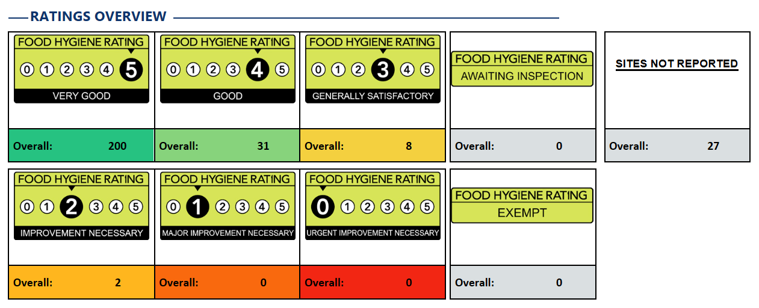
Note, there can be a delay in updating the FSAR system following visits

Staying Safe Together - “Our Skills”

i.Learn completion

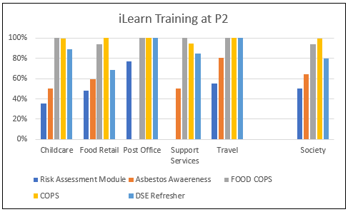

A total of 90% of planned i.Learn training has been completed in the Workjam to date with main shortfall from the new Risk Assessment Module (50% completed) and Asbestos Awareness training (64% completed)

New starters/ onboarding

Claire McCarthy will provide an update on the current on-boarding position and plans for 2024 L&D
platform during the Committee Meeting

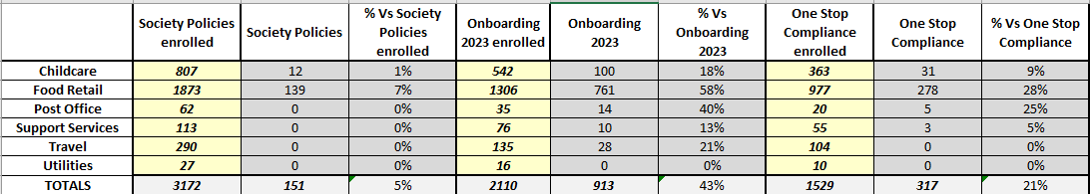

Training related H&S and Food Safety Audit actions

Although the audit program action review practice is greatly improved (compared with previous C365 activity) since migrating to WorkJam, there are a high number of overdue actions that sites need to review and action. The audit program has generated @800 actions and recommendations.

Nearly 30% of “Training” related actions are now showing as overdue and should be reviewed in Workjam with a view to closing out.

